<li class="point"><a href="http://127.0.0.1:5501/Project/Series.html">Series</a></li>

                        <li class="point"><a href="http://127.0.0.1:5501/Project/MatriXfigure.html">Matrix Figure</a></li>

                        <li class="point"><a href="http://127.0.0.1:5501/Project/PatternMatching.html">Pattern Matching</a></li>

                        <li class="point"><a href="http://127.0.0.1:5501/Project/PaperFolding.html">Paper Folding</a></li>

                        <li class="point"><a href="http://127.0.0.1:5501/Project/Series.html">Dot Situation</a></li>

                        <li class="point"><a href="http://127.0.0.1:5501/Project/AnalogyNV.html">Analogy</a></li>

                        <li class="point"><a href="http://127.0.0.1:5501/Project/CubesDice.html">Cubes & Dice</a></li>

                        <li class="point"><a href="http://127.0.0.1:5501/Project/RuleDetection.html">Rule Detection</a></li>

                        <li class="point"><a href="http://127.0.0.1:5501/Project/Classification.html">Classification</a></li>

                        <li class="point"><a href="http://127.0.0.1:5501/Project/MirrorImages.html">Mirror Images & Reflection</a></li>

                        <li class="point"><a

href="http://127.0.0.1:5501/Project/CountingOfFigures.html">Counting of Figures</a></li>

Series

Number Series, it refers to a sequence of numbers following some pattern.

There is no set pattern and each question in number series reasoning may follow a different type of pattern or sequential arrangement

of letters or digits, which candidates need to detect using their common sense and reasoning ability.

Types of Number Series

1. Addition Number Series: Specific numbers based on some pattern are added to get the next number.

2. Subtraction Number Series:Specific numbers based on some pattern are subtracted to get the next number.

3. Multiplication Number Series:  A particular type of number pattern is multiplied to get the next number.

4. Division Number Series:  A particular type of number pattern is divided to get the next number.

5. Square Number Series: Each number is a perfect square of a particular number pattern.

6. Cube Number Series: Each number is a perfect cube of a particular number pattern.

7. Fibonacci Number Series:  The next number is the addition of two previous numbers.

8. Alternating Number Series:  Multiple number patterns are used alternatively to form a series.

9. Mixed Operator Number Series:  Multiple operators are applied to get the next number in the series.

10. Arranging Number Series: In these type of number series reasoning questions, candidates need to rearrange numbers, as specified, and then answer the given questions

**Q1).**Given a Series 50, 45, 40, 35, 30, ?   
Find what number would come in place of the question mark(?).

a) 28

b) 15

c) 25

d)  20

***Answer :****(c) 25*

***Explanation :***

*If you observe the pattern, then you will see, it’s nothing but constant difference series.*

*50 – 5 = 45*

*45 – 5 = 40*

*40 – 5 = 35*

*35 – 5 = 30*

*30 – 5 = 25*

*Hence, the correct answer is**25.*

Q. 2) Find the number which will come in the place of the question mark in the given series 11,12,15,20,27,?

a) 36

b) 35

c) 38

d)  41

***Answer :****(a) 36*

***Explanation:-***

*Here, the series follows a pattern of the sum of consecutive odd numbers.*

*11 + 1 = 12*

*12 + 3 = 15*

*15 + 5 = 20*

*20 + 7 = 27*

*27 + 9 = 36.*

*Hence, the missing number would be 36.*

Q.3) Find the number which would come in place of question mark 81 : 101 ::  121 : ? .

a) 141

b) 143

c) 170

d)  145

***Answer :****(d) 145*

***Explanation:-***

*Here 81 is nothing but 92*

*and 101 is nothing but (9 + 1)2 +1*

*So, likewise this*

*121 is nothing but 112*

*so ,next term will be (11 + 1)2 + 1 = 145*

Q.4) Find the number which would come in place of question mark 2, 4,  8, 10, 14, ?.

a) 16

b) 18

c) 24

d)  20

***Answer :****(a) 16*

***Explanation:-***

*This series is an alternating series, where a pattern following is +2, +4, +2, +4, and so on*

*2 + 2 = 4*

*4 + 4 = 8*

*8 + 2 = 10*

*10 + 4 = 14*

*14 + 2 = 16*

*Hence the next term will be 16.*

Q.5) Find the number which would come in place of question mark  6, 11,18,27, ?.

a) 33

b) 40

c) 38

d)  81

***Answer :****(c)  38*

***Explanation:-***

*Here, every term is squares from (starting from 2 ) with the addition of 2.*

*22 + 2 = 6*

*32 + 2 =11*

*42 + 2 = 18*

*52 + 2 = 27*

*62 + 2 = 38*

*Q.6)* 1, 2, 3, 10, ?, 9802

|  |  |
| --- | --- |
| A) 99 | B) 199 |
| C) 299 | D) 999 |

[Answer & Explanation](javascript:showans('7318','Number%20Series'))**Answer:** A) 99  
  
**Explanation:**

2 = 12 + 1

3 = 22 – 1

10 = 32 + 1

102 − 1 = 99

9802 = 992 + 1

Q.7) Find the missing term in the following series ?

10000, 11000, 9900, 10890, ?, 10781

|  |  |
| --- | --- |
| A) 10423 | B) 9801 |
| C) 10241 | D) 9712 |

[Answer & Explanation](javascript:showans('11099','Number%20Series'))**Answer:** B) 9801  
  
**Explanation:**

Clearly, alternatively we add and subtract 10% of a term to obtain the next term of the series.  
Thus, 10000 + (10% of 10000)= 11000;  
11000 - (10% of 11000) = 9900;  
 9900 + (10% of 9900)  = 10890;  
10890 - (10% of 10890) = 9801.  
 9801 + (10% of 9801)  = 9801+980 = 10781.  
So, missing term = 10890- (10% of 10890)= 9801.

Q.8) 13 17 23 29 31 37 ??

1. 22

2. 41

3. 19

4. 23

5. 27

Answer & Explanation

**Sol: Option** 2  
**Explanation:** The given series is a prime number series. Hence the next prime number in this sequence would be 41.

Q.9) 1, 125, 729, 2177

1. 2177

2. 729

3. 125

4. 1

5. 121

Answer & Explanation

**Sol: Option** 1  
**Explanation:** 1, 125, 729, 2177  
1 = 13 , 125 = 53, 729 = 93. So, next number would be 133= 2197  
Therefore, 2177 is wrong.

1. 17 16 14 12 11 8 8 ?

1. 4

2. 7

3. 3

4. 2

5. None of the above

Answer & Explanation

**Sol: Option** 1  
**Explanation:** There are two series:  
Ist : 17 14 11 8 and 2nd: 16 12 8 ?  
In first series, -3 , -3 ,-3….. and in 2nd series , -4 , -4 ,-4….  
Therefore, next term will be 8 – 4 = 4.

Matrix Figure

Figure Matrix questions contain a grouping of diagrams or figures in the shape of a rectangular matrix. This arrangement of diagrams in the form of a [matrix](https://www.toppr.com/guides/maths/matrices/matrix/) forms the Figure Matrix. Each diagram in the figure matrix is there as a result of some rule. You will have to figure out this rule and make necessary decisions using this knowledge.

**Sample Example: Select the correct option from 1 to 8.**

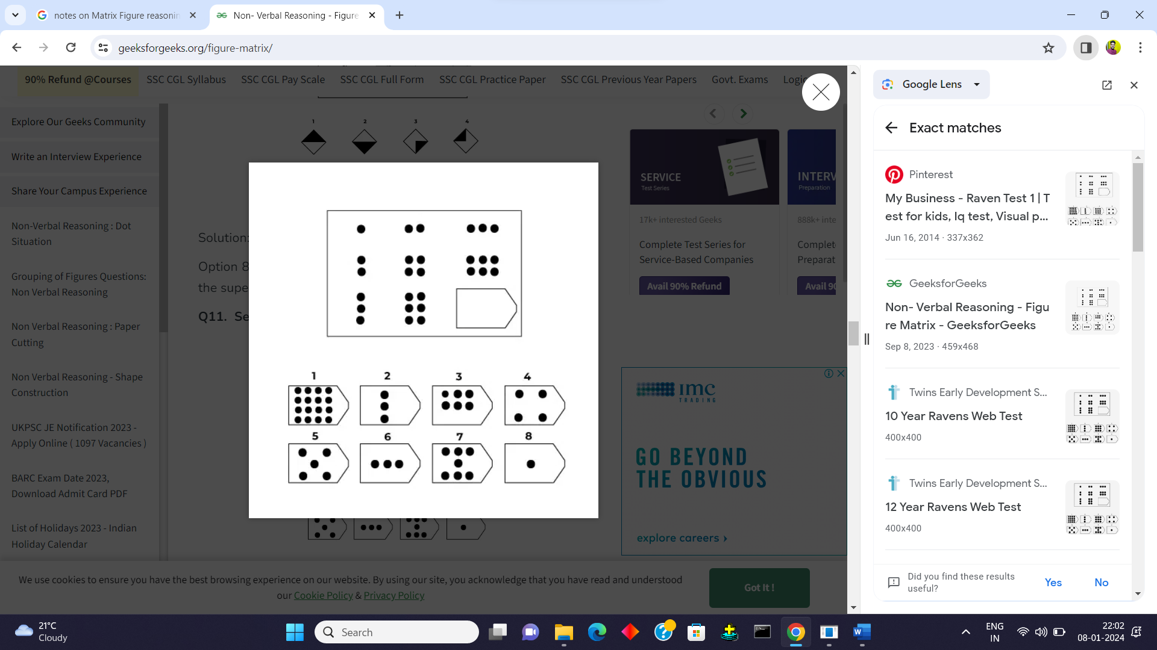

Solution:

Option 3 is the correct answer. As we can see in each row pattern is increasing. In row 1 circle increased from 1, 2, to 3, and in row 2 pair of two circles was added Similarly in row 3, the group of three circles increased.

Q.1) Select a suitable figure from the four alternatives that would complete the figure matrix.

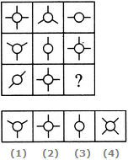

A1

B 2

C 3

D 4

**Answer:** Option A

**Explanation:**

Each row (as well as each column) contains a figure consisting of a circle and two line segments, a figure consisting of a circle and three line segments and a figure consisting of a circle and four line segments.

Q.2)

Select a suitable figure from the four alternatives that would complete the figure matrix.

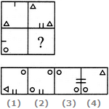

A1

B2

C3

D4

**Answer:** Option C

**Explanation:**

The second figure is obtained from the first figure by moving the line segment to the opposite side of the square boundary and replacing it with two similar line segments. Also, the element in the lower-left corner gets replaced by two similar elements - one placed in the upper-left and the other placed in the lower-right corner.

Q.3)

Select a suitable figure from the four alternatives that would complete the figure matrix.

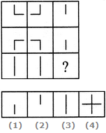

A1

B2

C3

D 4

**Answer:** Option C

**Explanation:**

In each row, the third figure is a collection of the common elements (line segments) of the first and the second figures.

Q.4)

Select a suitable figure from the four alternatives that would complete the figure matrix.

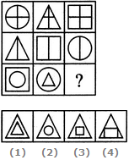

A1

B2

C3

D4

**Answer:** Option C

**Explanation:**

In each row, the triangle follows the circle, the square follows the triangle and the circle follows the square. In case of the third row, the above rule exists for the inner as well as the outer elements.

Q.5) In the following question, find out which of the answer figures (a), (b), (c) and (d) completes the figure matrix?

Problem Figure:

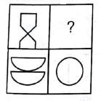

Answer figures:

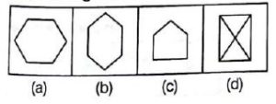

1. (a)
2. (b)
3. (c)
4. (d)
5. none of the above

Answer: The two parts of the first figure are rearranged and joined along the longer sides. The common side is then removed to form the second figure. Hence the answer is B. (b).

Q.6) : In the following question, find out which of the answer figures (a), (b), (c) and (d) completes the figure matrix?

Problem Figure:

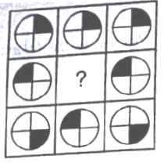

Answer Figures:

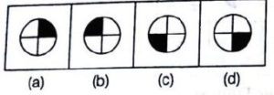

1. (a)
2. (b)
3. (c)
4. (d)
5. none of the above

Answer: In the first and the third set, the black portion of the middle image is diagonally opposite to that of the first image. Hence, the second image in the second set must be the option D. (d).

Q.7) **Q:** In each of the following questions, find out which of the answer figures (a), (b), (c) and (d) completes the figure matrix ?

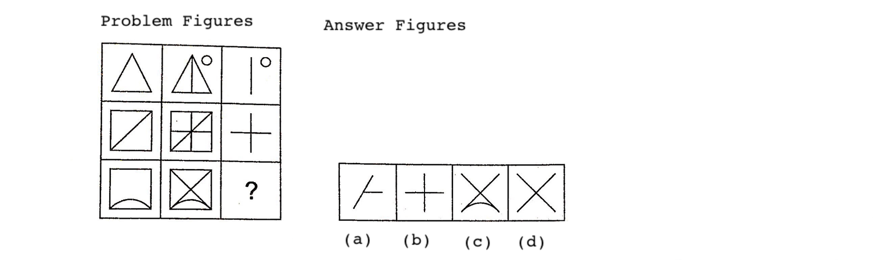

**Solution: (d)** The third figure in each row comprises of parts which are not common to the first two figures.

Q.8) **Q:**

Select a suitable figure from the four alternatives that would complete the figure matrix.

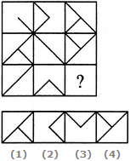

|  |  |
| --- | --- |
| A) 3 | B) 1 |
| C) 2 | D) 4 |

[Answer & Explanation](javascript:showans('10909','Figure%20Matrix'))**Answer:** C) 2  
  
**Explanation:**

The third figure in each row comprises of parts which are not common to the first two figures.

Q.9) Select a suitable figure from the four alternatives that would complete the figure matrix.

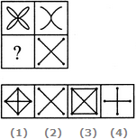

|  |  |
| --- | --- |
| A) 4 | B) 3 |
| C) 2 | D) 1 |

[Answer & Explanation](javascript:showans('10906','Figure%20Matrix'))**Answer:** B) 3  
  
**Explanation:**

In each row, the third figure is a collection of the common elements (line segments) of the first and the second figures.

Q.10) **Q2. Select a suitable figure from the four alternatives to complete the figure matrix.**

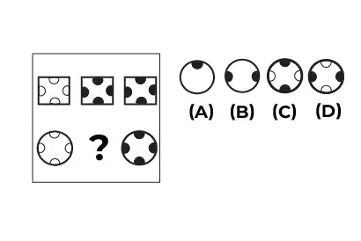

Solution: **[use a, b, c ,d to form options]**

The correct answer is (c), we can see that the opposite two semicircles are filling up as we move towards the right. The circles that are filled are vertical semicircles.

Pattern matching

In this problem a figure is given which contain set of figure or matrix containing and that followed some pattern some pattern or sequence in which a quarter is left blank. Side by side another four pattern or sequence are given and choose one from that fits into the blank space.

Sample Example:Choose the alternative which is closely resembles the Missing Pattern of the given figure.

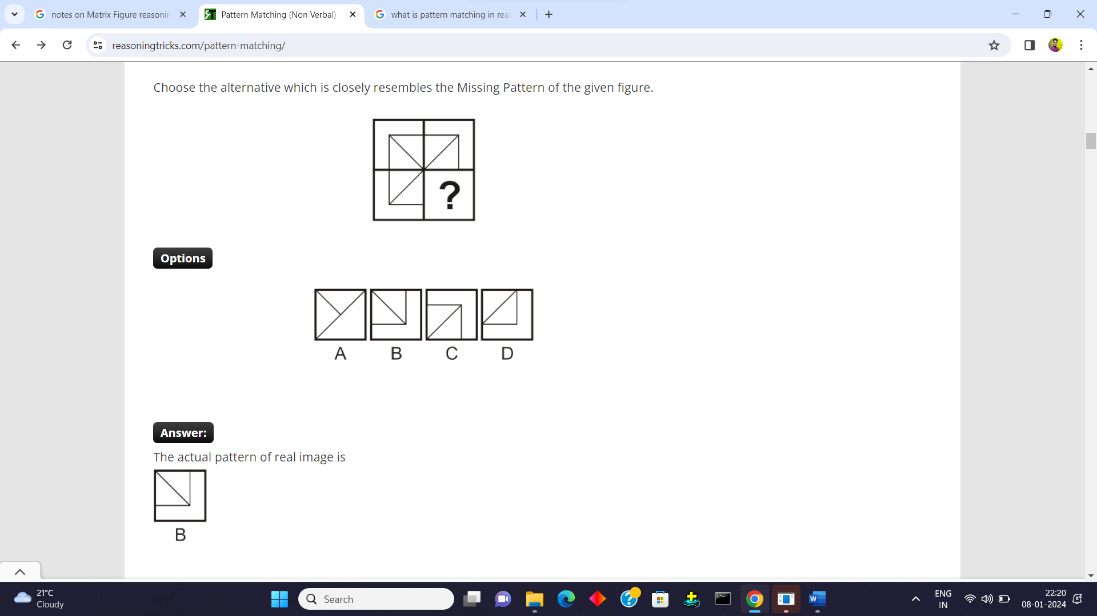



1). Identify the figure that completes the pattern.

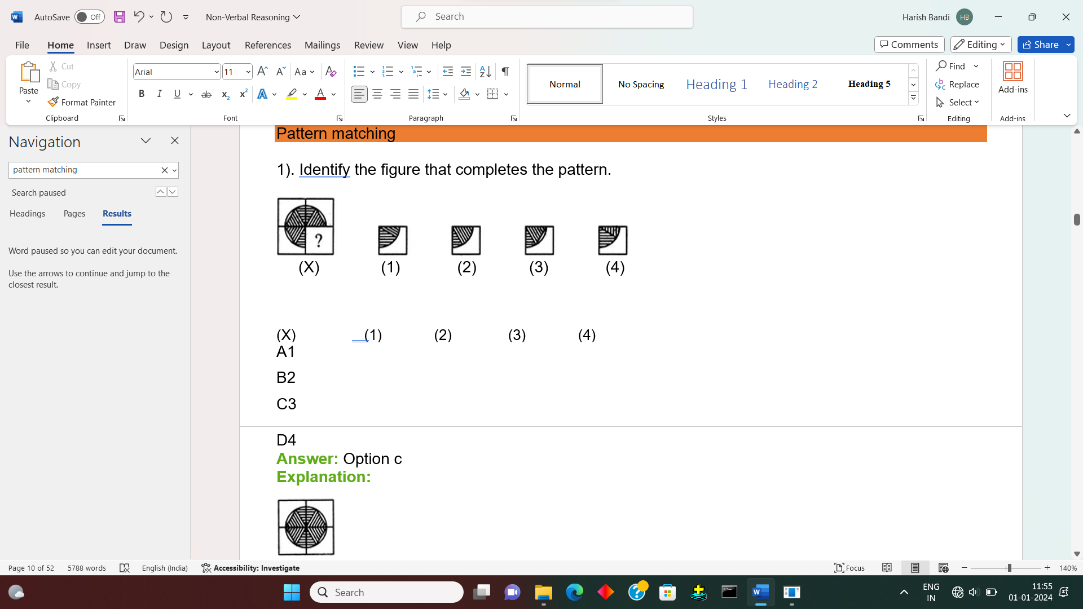

A1

B2

C3

D4

**Answer:** Option c

**Explanation:**



Q. 2.

Identify the figure that completes the pattern.

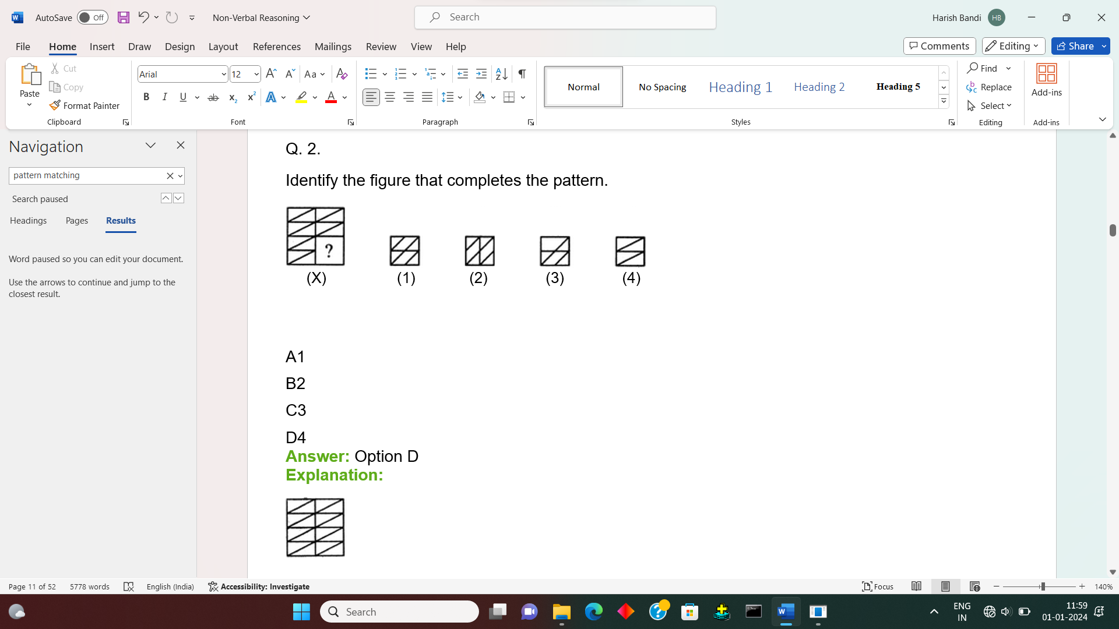

A1

B2

C3

D4

**Answer:** Option D

**Explanation:**



Q. 3.

Identify the figure that completes the pattern.

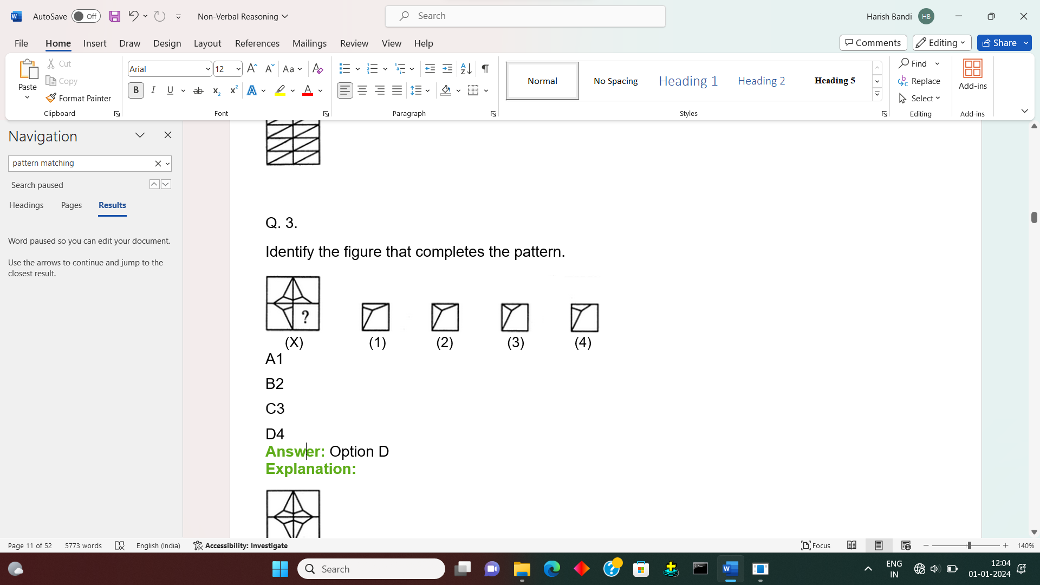

A1

B2

C3

D4

**Answer:** Option D

**Explanation:**



Q. 4  
Identify the figure that completes the pattern.

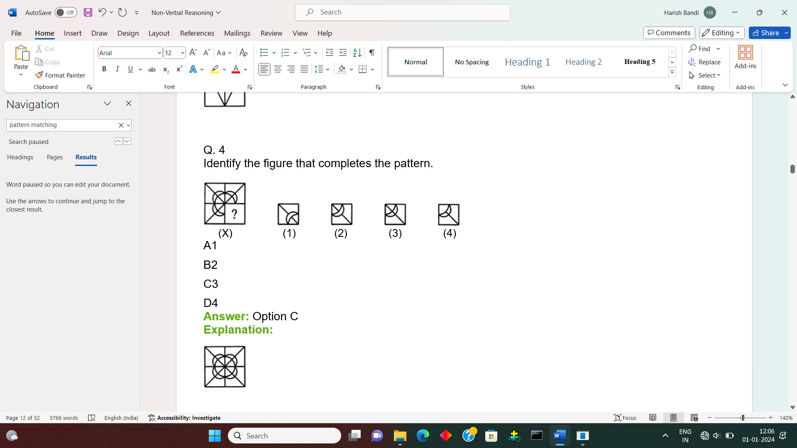

A1

B2

C3

D4

**Answer:** Option C

**Explanation:**



Q.5)

Identify the figure that completes the pattern.

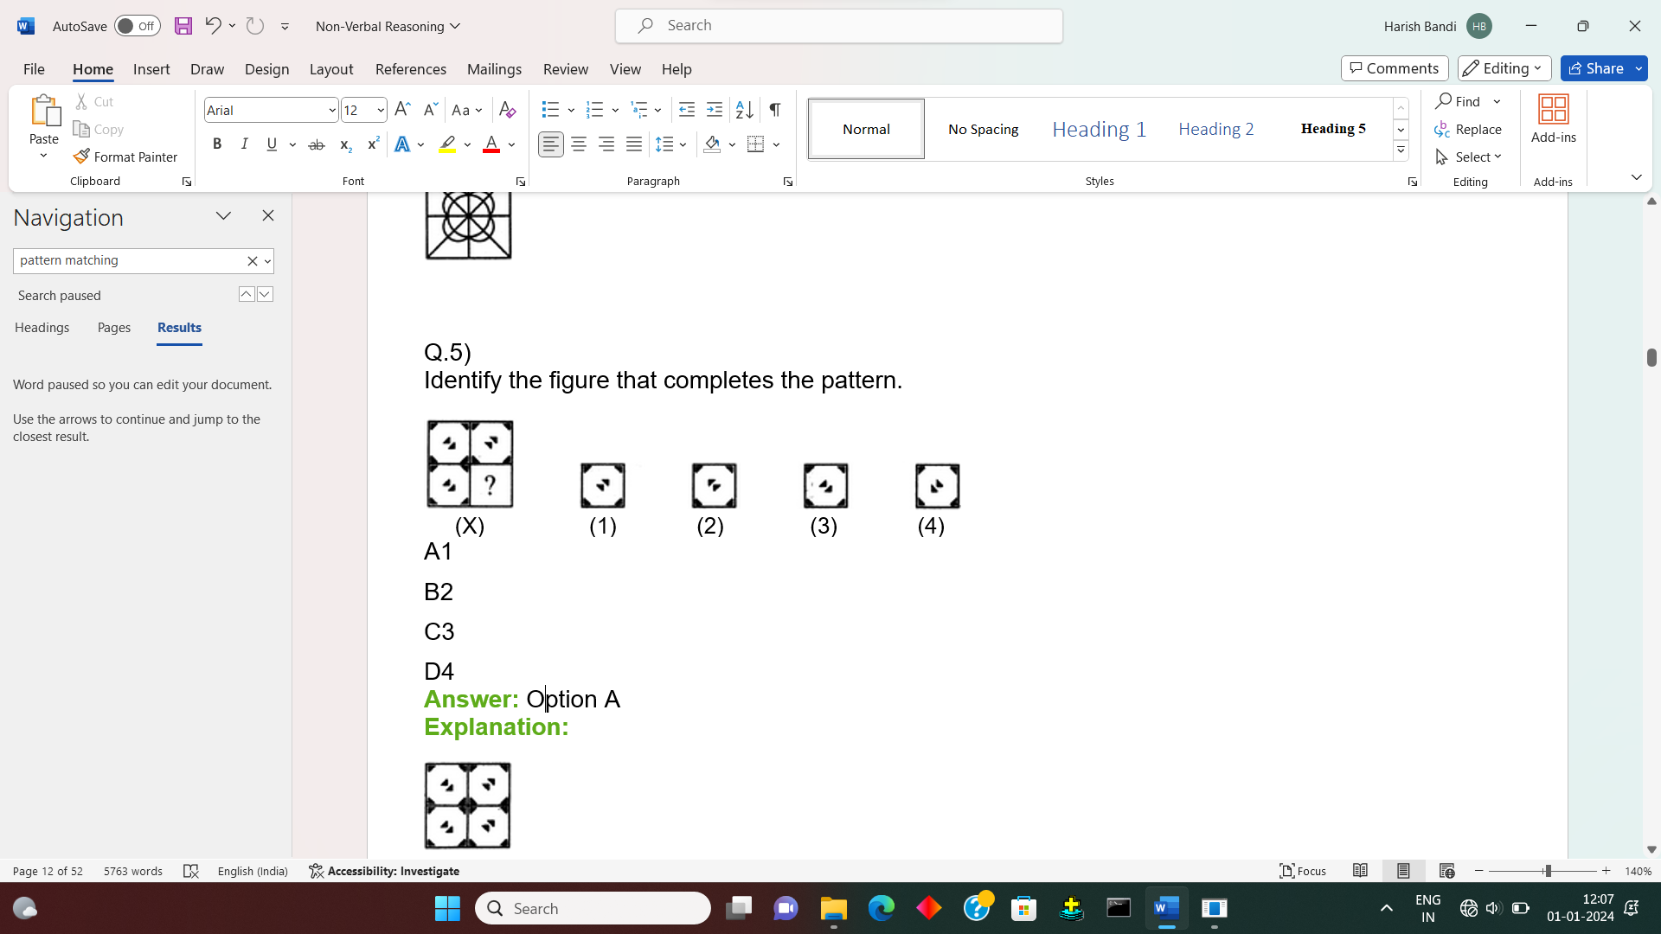

A1

B2

C3

D4

**Answer:** Option A

**Explanation:**



Q.6)

Identify the figure that completes the pattern.

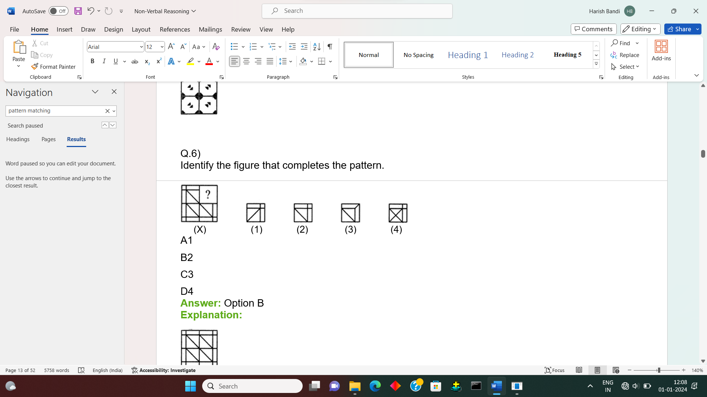

A1

B2

C3

D4

**Answer:** Option B

**Explanation:**



Q.7 Following question has four alternatives, among which one completes the figures.

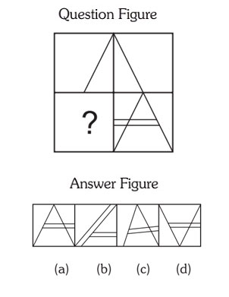

1. 
   1. Option **(a)** in Answer Figure.



* 1. Option **(b)** in Answer Figure.



* 1. Option **(c)** in Answer Figure.



* 1. Option **(d)** in Answer Figure.

1. [View Hint](https://interviewmania.com/non-verbal-reasoning/completion-of-incomplete-pattern) [View Answer](https://interviewmania.com/non-verbal-reasoning/completion-of-incomplete-pattern) [Discuss in Forum](https://interviewmania.com/discussion/27167-non-verbal-reasoning-completion-of-incomplete-pattern)

**Correct Option: A**

Right Side figure contains the complete triangle with double across. So the **(a)** option in given figure will complete the figures.

Q.8)

Identify the figure that completes the pattern.

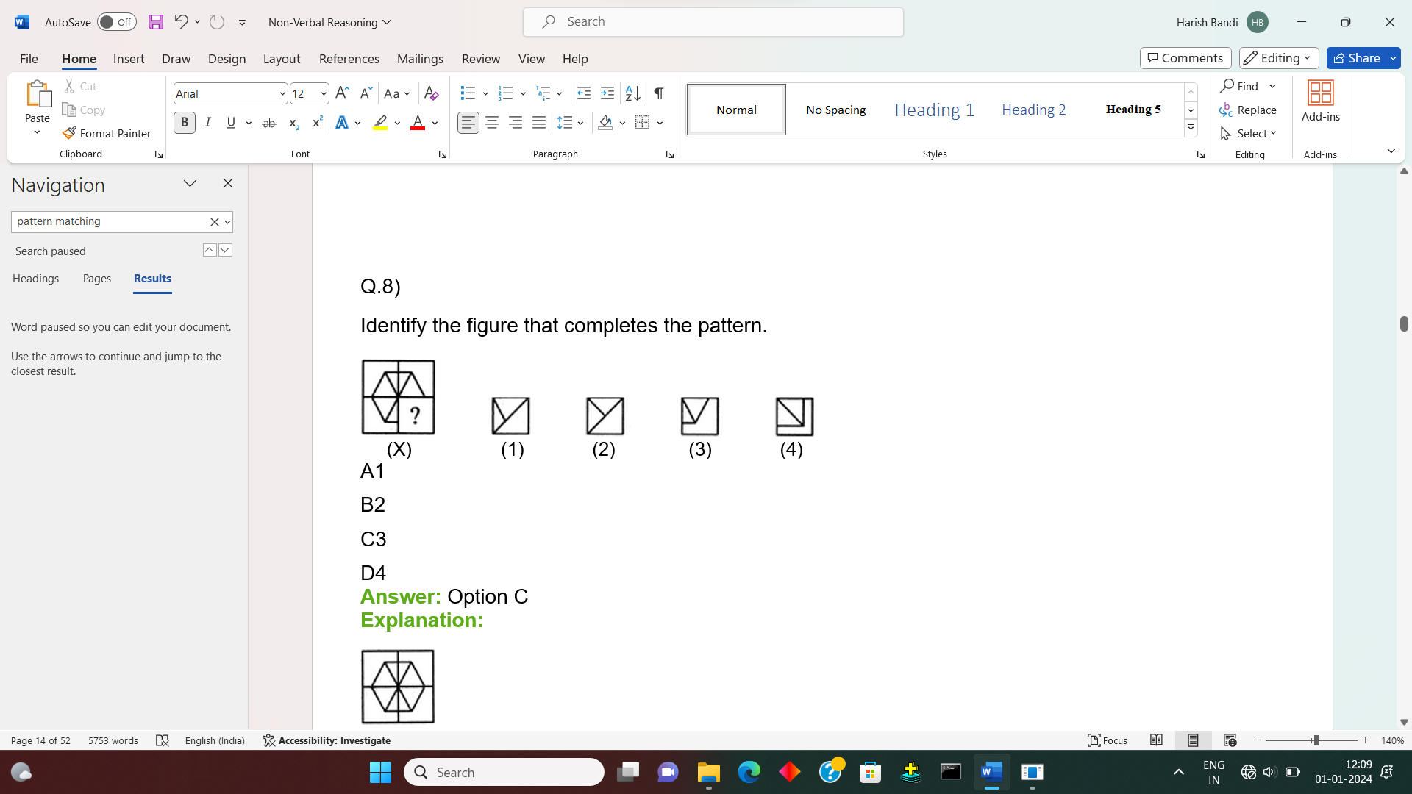

A1

B2

C3

D4

**Answer:** Option C

**Explanation:**



Q.9) 45.

Identify the figure that completes the pattern.

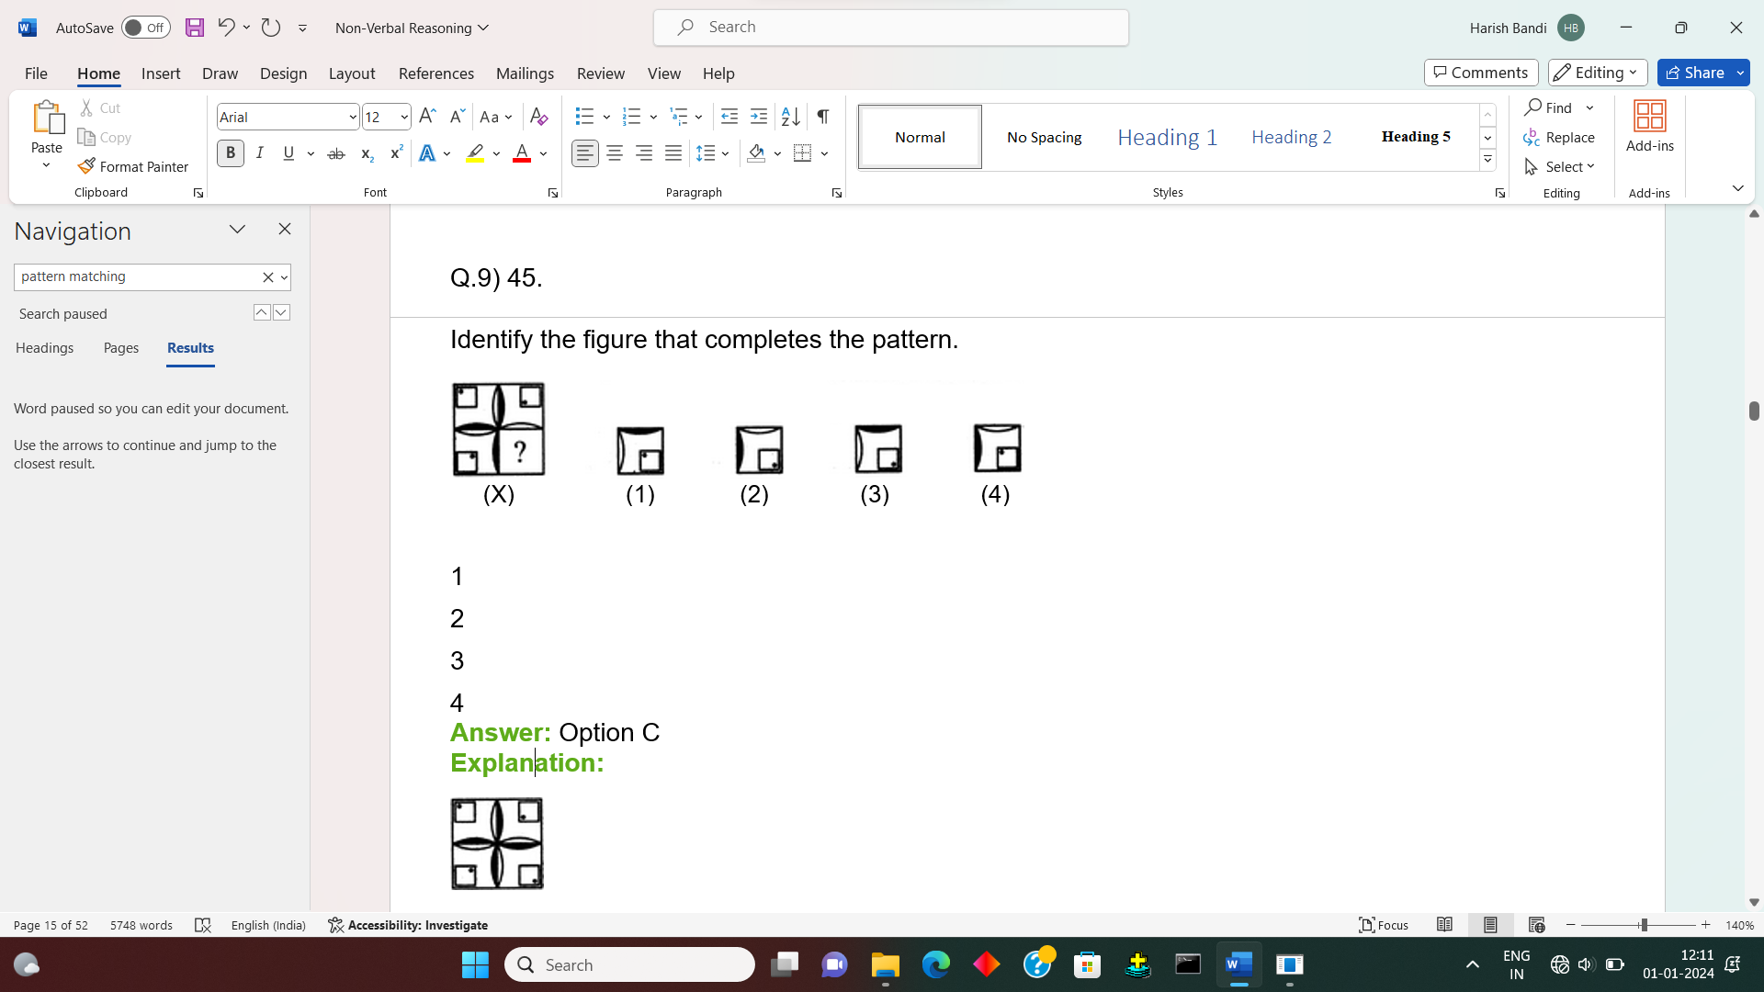

1

2

3

4

**Answer:** Option C

**Explanation:**



10) Identify the figure that completes the pattern.

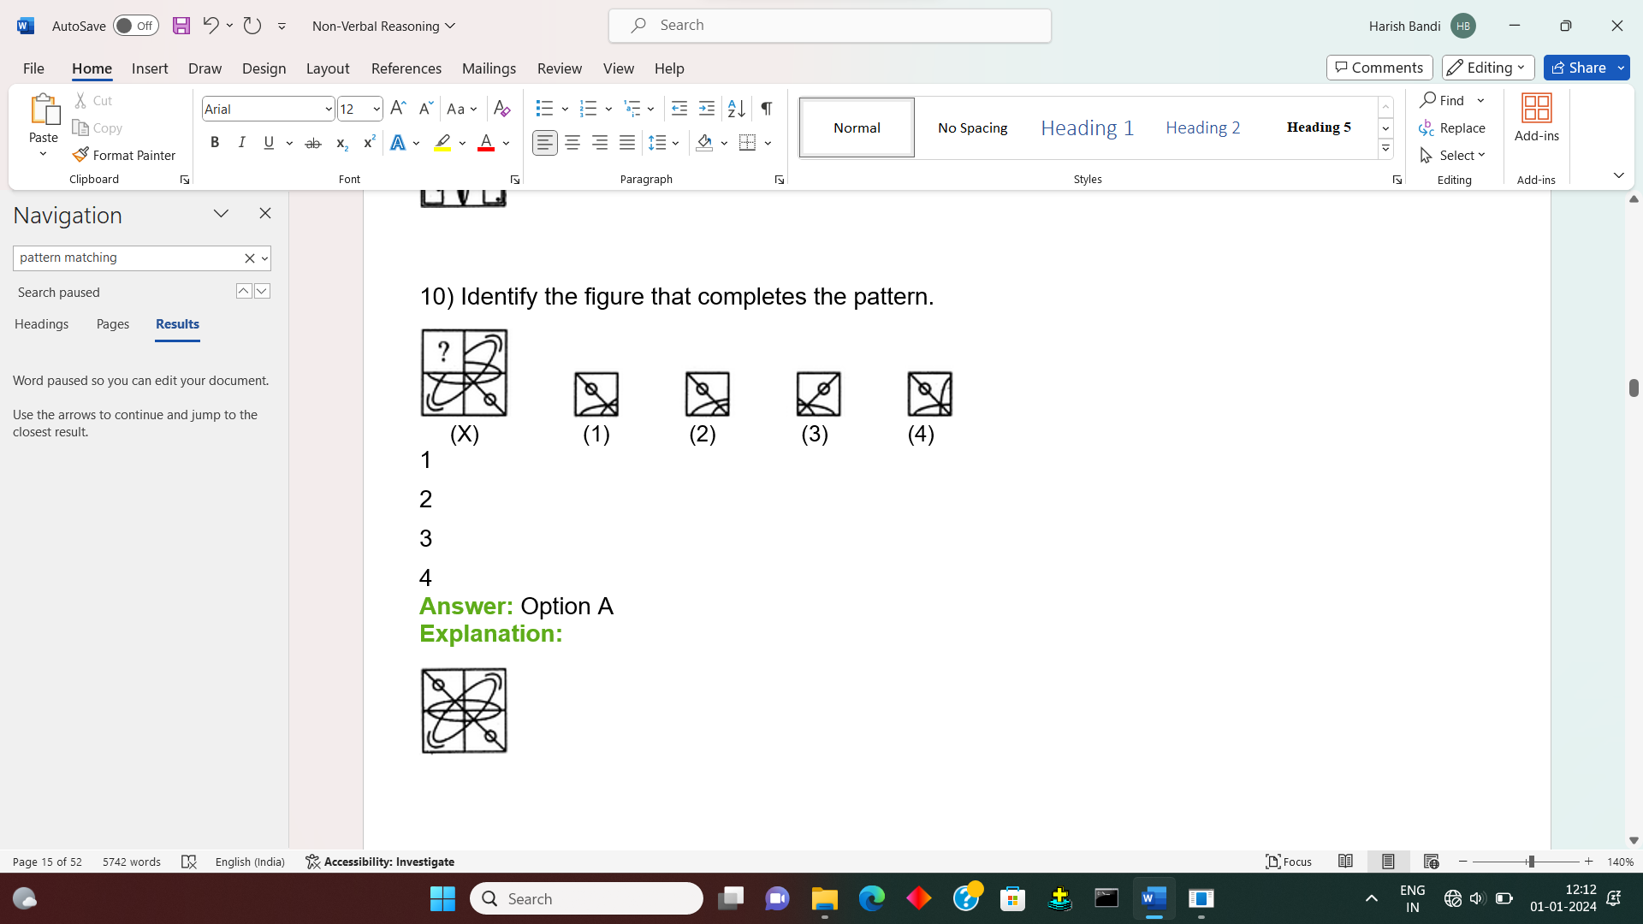

1

2

3

4

**Answer:** Option A

**Explanation:**



Paper folding

In the questions based on Paper Folding and Cutting a few [figures](https://www.toppr.com/guides/reasoning-ability/images/grouping-of-figures/) are given showing the way in which a piece is to be folded and then cut from a particular section. The dotted line is the reference line along which the paper is to be folded and the arrow indicates the [direction](https://www.toppr.com/guides/business-management-and-entrepreneurship/direction-and-coordination/elements-of-direction-motivation/) of the fold.

Thus, these figures indicate the [sequence](https://www.toppr.com/guides/maths/sequences-and-Series/introduction-to-sequences-and-series/) in which the paper is to be folded. The designs from the cut will appear on each one of the folds made on the paper. In questions based on paper folding and cutting it can be asked to find either the folded or unfolded pattern of the sheet. Let us see sample example.

Sample Example:

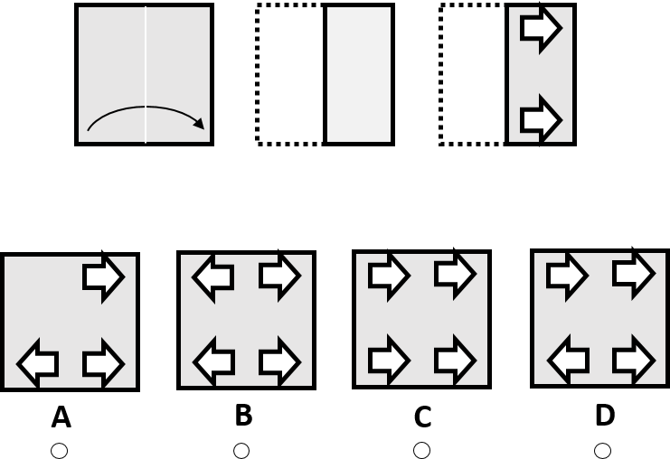

The figures at the top represent a square piece of paper being folded, and the last of these figures has one hole on it.

One of the lower five figures shows where the perforation will be when the paper is fully unfolded. You have to understand which of these images is the right one.

**First, the paper was folded horizontally, from left to right.**

**Then, one holes were punched out. Therefore, when the paper is unfolded the holes will mirror on the left and right side of the sheet.**

**The right answer is “B”.**

Q.1) Find out from amongst the four alternatives as to how the pattern would appear when the transparent sheet is folded at the dotted line.

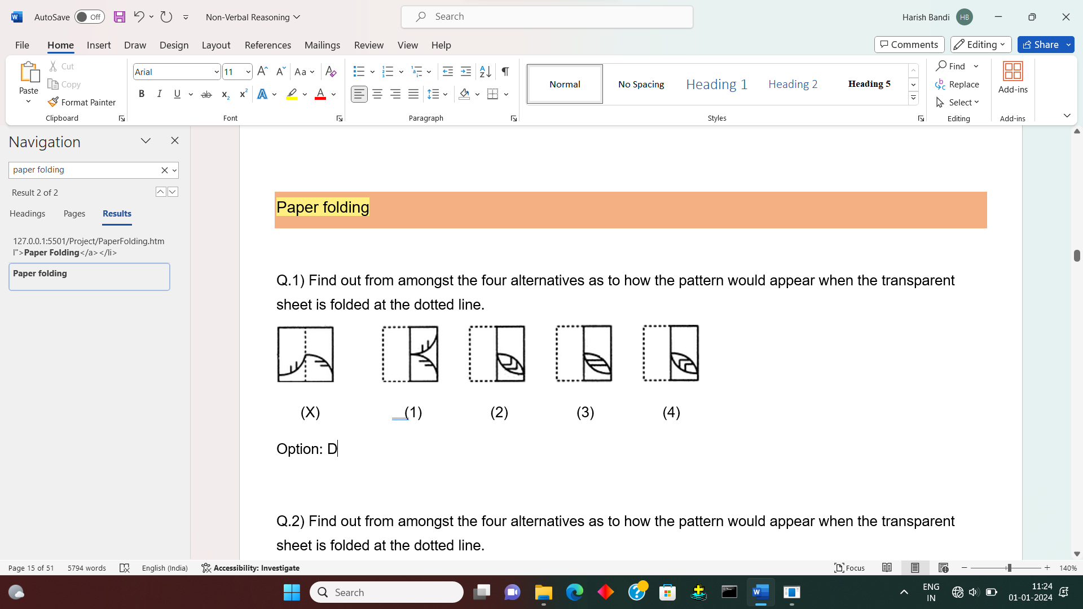

Option: D

Q.2) Find out from amongst the four alternatives as to how the pattern would appear when the transparent sheet is folded at the dotted line.

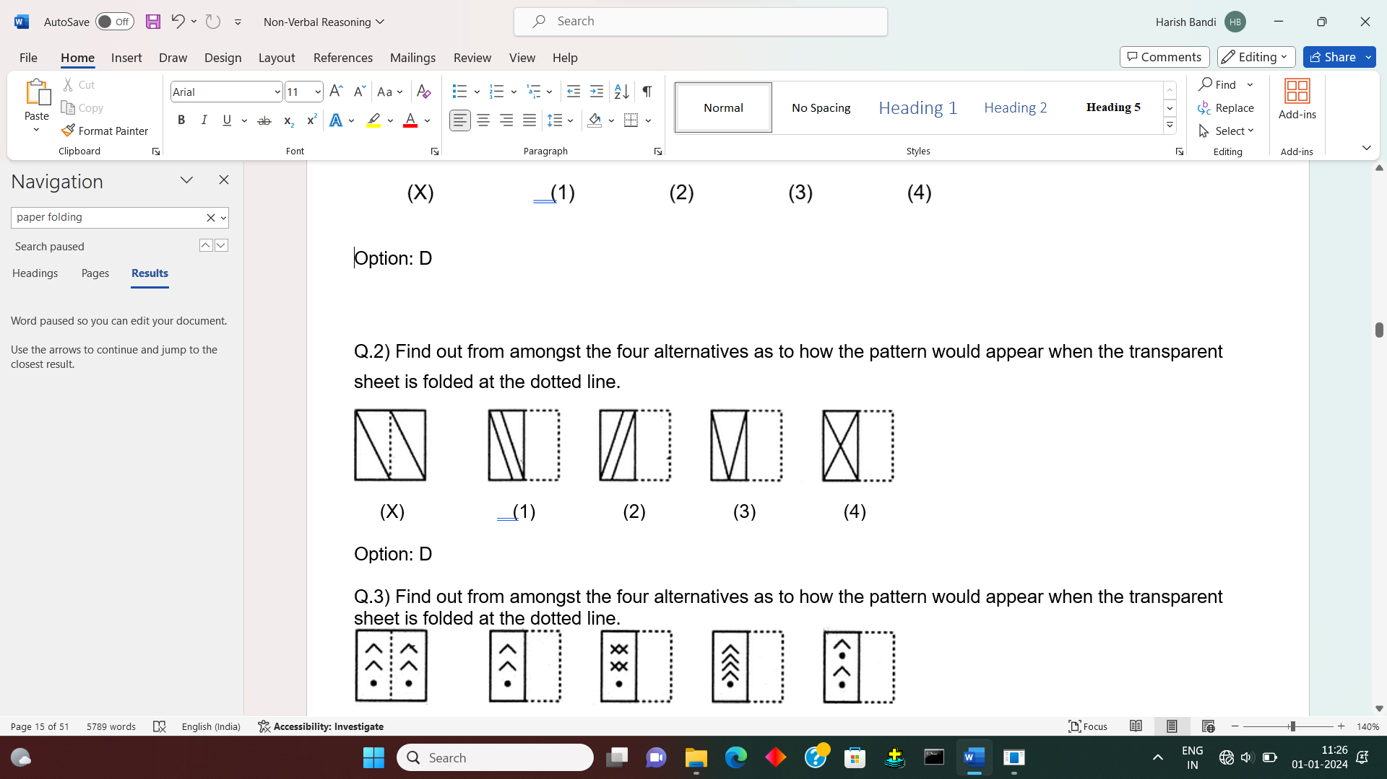

Option: D

Q.3) Find out from amongst the four alternatives as to how the pattern would appear when the transparent sheet is folded at the dotted line.

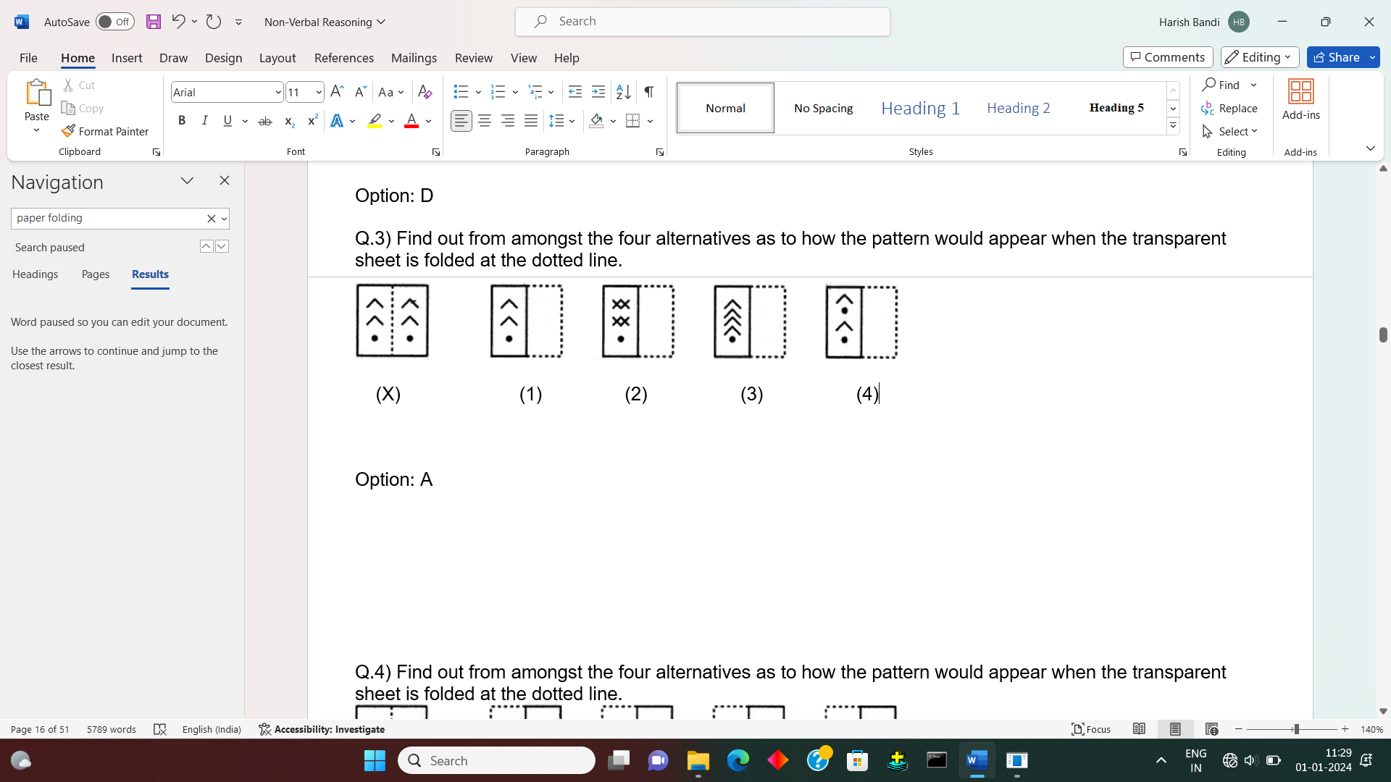

Option: A

Q.4) Find out from amongst the four alternatives as to how the pattern would appear when the transparent sheet is folded at the dotted line.

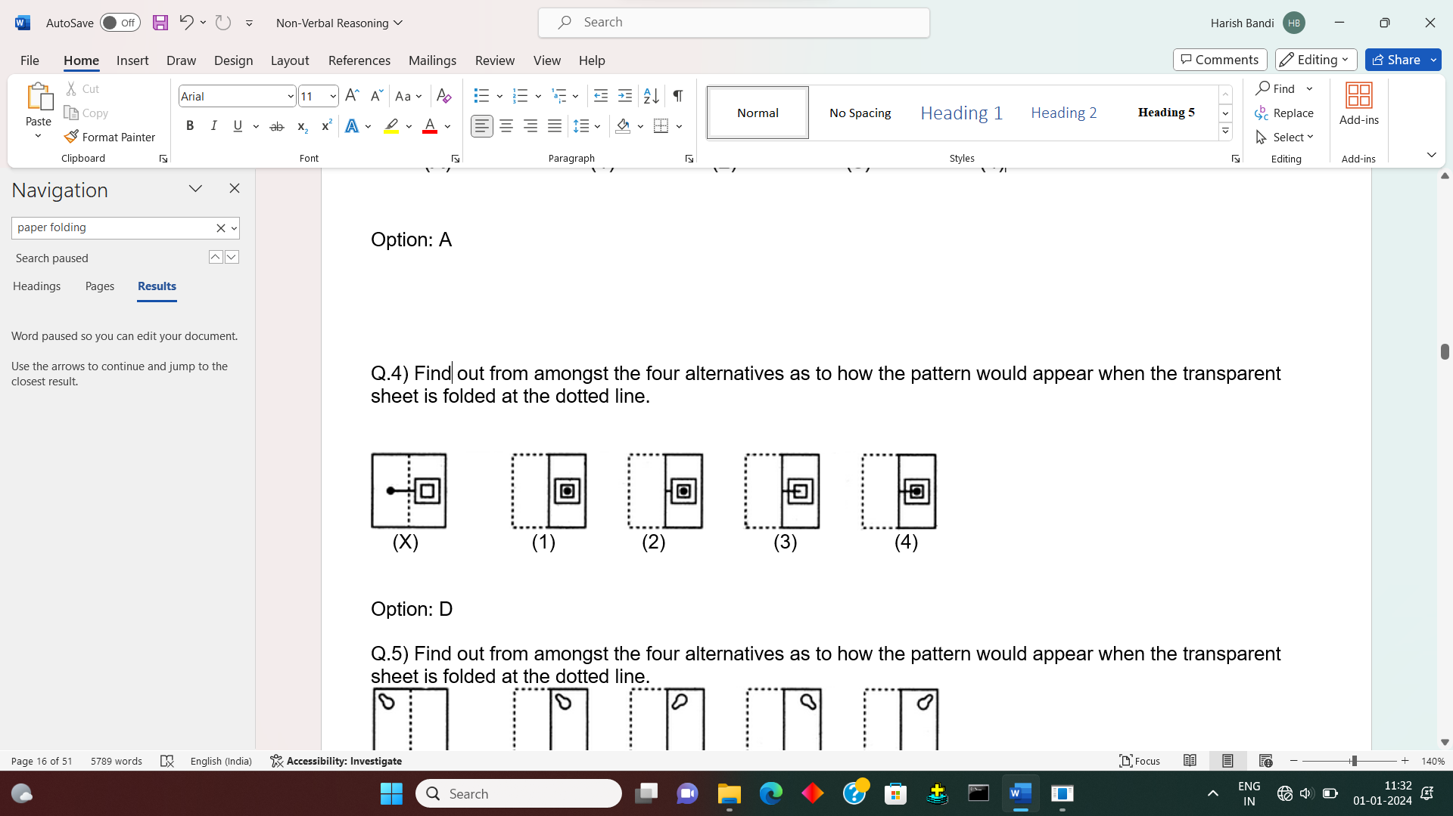

Option: D

Q.5) Find out from amongst the four alternatives as to how the pattern would appear when the transparent sheet is folded at the dotted line.

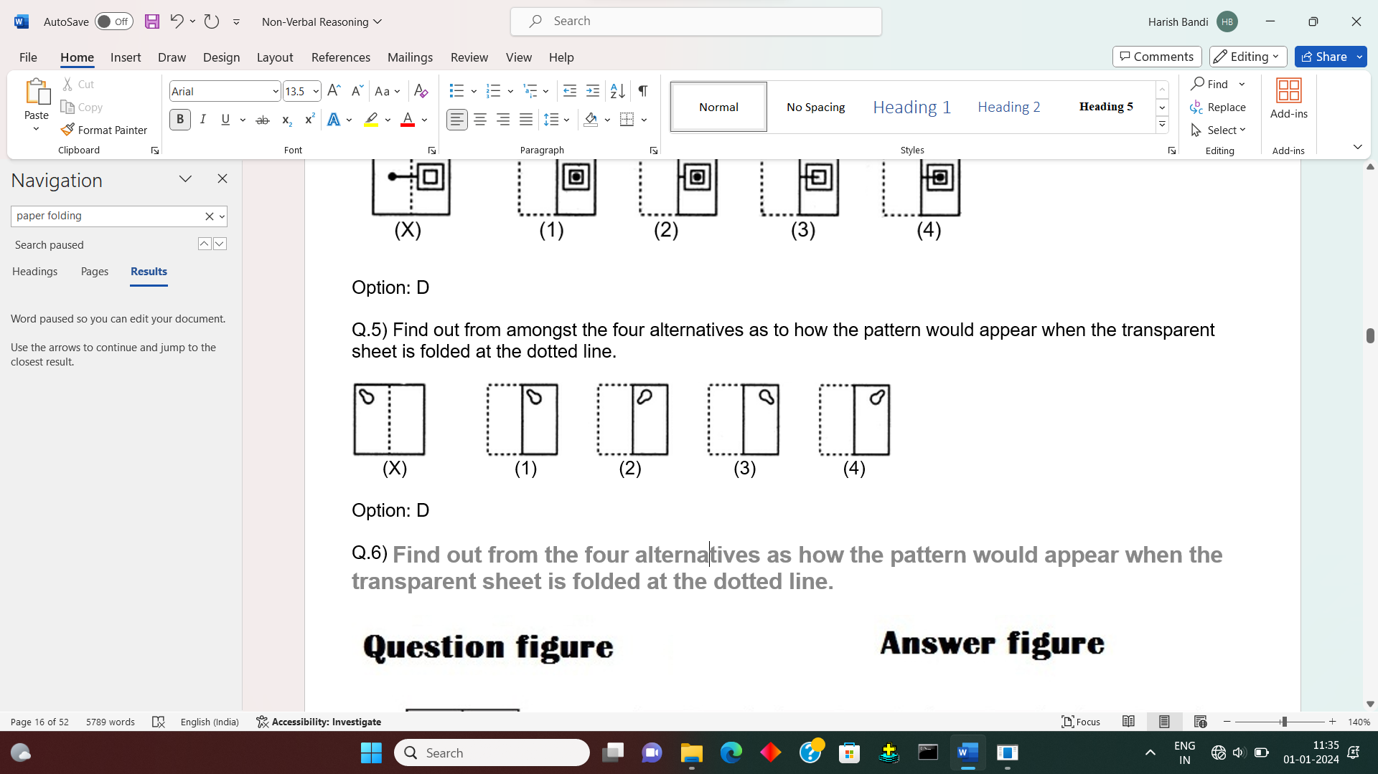

Option: D

Q.6) **Find out from the four alternatives as how the pattern would appear when the transparent sheet is folded at the dotted line.**

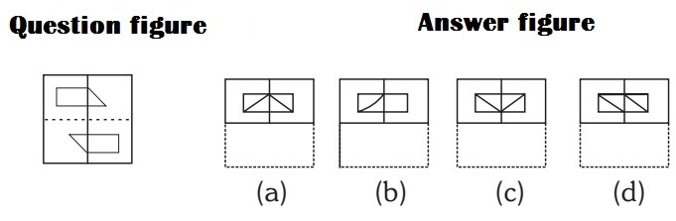

##### Correct Option: A

If you fold the paper in upward direction from dotted line, the upper line of the figure will be near to middle line. So it will make s triangle. Please take a transparent paper and draw a similar figure and fold it.

Q.7) **Find out from the four alternatives as how the pattern would appear when the transparent sheet is folded at the dotted line.**

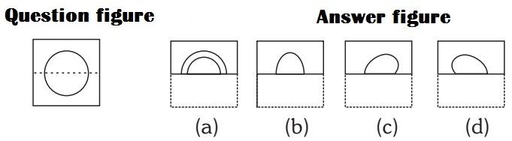

##### Correct Option: B

If you fold the lower part to upper direction from dotted line , it will cover the upper part figure exactly and will make half circle.

Q.8) **Find out from the four alternatives as how the pattern would appear when the transparent sheet is folded at the dotted line.**

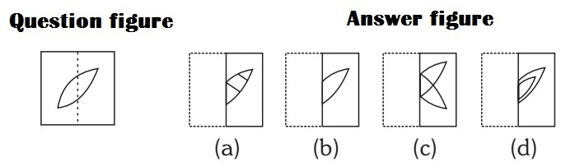

##### Correct Option: C

If you fold the paper from left to right from dotted line, the left part figure will go in opposite direction. Please take a transparent paper and draw a similar figure and fold it.

Q.9) A round punched paper is given as shown in the question figure. Figure out from the four alternatives as to how it will appear when folded.

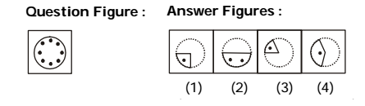

**Correct Option: C**

Q.10) A piece of paper is folded and cut as shown below in the question figures. From the given answer figures, indicate how it will appear when opened.

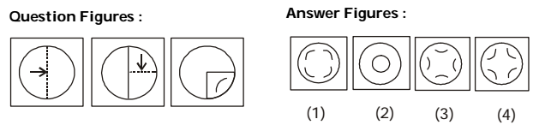

**Correct Option: D**

Dot situation

The problem on dot situation involve a cluster of three or more geometrical figures-usually triangle, square, rectangle or/and circle one or more dots placed at any point inside the cluster. This cluster is followed by a set of four alternative figures each composed of a cluster of same type of figures. Now, for each dot we have to observe the region in which it is enclosed, i.e.to which of the geometrical figures this region is common, then, we look for such a region in the four alternatives. Once we have found it, we repeat the procedure for other dots if any. The alternative figure which contains all such regions is the answer.

Sample Example:

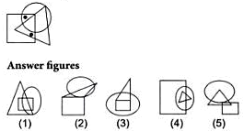

In the problem figure, there are two dots. One dot appears in a region common to both circle and square only and another dot appears in a region common to both triangle and square only. Such a region is present only in the answer figure (1).  
Choice (1)

Q.1) Select the figure which satisfies the same conditions of placement of the dots as in Figure-X.

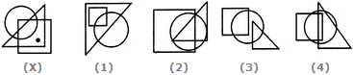

1

2

3

4

**Answer:** Option A

**Explanation:**

In fig. (X), the dot is contained in the region common to the triangle and the square only. Out of the four alternatives, only fig. (1) contains a region common to the triangle and the square only.

Q.2) Select the figure which satisfies the same conditions of placement of the dots as in Figure-X.

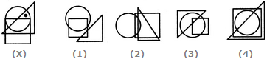

1

2

3

4

**Answer:** Option C

**Explanation:**

In fig. (X), the dot is contained in the region common to the triangle and the circle only. Out of the four alternatives, only fig. (3) contains a region common to the triangle and the circle only.

Q.3) Select the figure which satisfies the same conditions of placement of the dots as in Figure-X.

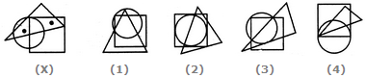

1

2

3

4

**Answer:** Option A

**Explanation:**

In fig. (X), one of the dots lies in the region common to the circle and the triangle only and the other dot lies in the region common to the square and the triangle only. In each of the figures (2), (3) and (4), there is no region common to the circle and the triangle only. Only fig. (1) consists of both the types of regions.

Q.4) Select the figure which satisfies the same conditions of placement of the dots as in Figure-X.

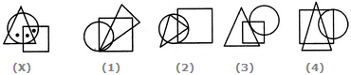

1

2

3

4

**Answer:** Option B

**Explanation:**

In fig. (X), one of the dots lies in the region common to the circle and the square only, another dot lies in the region common to all the three figures - the circle, the square and the triangle and the third dot lies in the region common to the circle and the triangle only. In each of the alternatives (1), (3) and (4), there is no region common to the circle and the triangle only. Only fig. (2) consists of all the three types of regions.

Q.5) Select the figure which satisfies the same conditions of placement of the dots as in Figure-X.

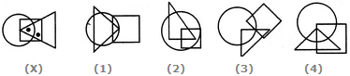

1

2

3

4

**Answer:** Option D

**Explanation:**

In fig. (X), one of the dots lies in the region common to the square and the triangle only and the other dot lies in the region common to all the three figures - the circle, the square and the triangle. In each of the alternatives (1) and (2), there is no region common to the square and the triangle only. In alternative (3), there is no region common to all the three figures. Only, alternative (4) consists of both the types of regions.

Q.6) Select the appropriate alternatives, from among the answer figures marked (1), (2), (3), (4) and (5), satisfying the similar conditions of placement of dot(s) as in the problem figure.

**Question 1**  
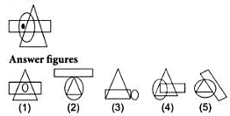

**Solution:** In the problem figure, one dot appers in a region common to both circle and rectangle only. Such a region is present in the answer figure (5). Choice (5)

**Q.7)** Select the figure which satisfies the same conditions of placement of the dots as in Figure-X.

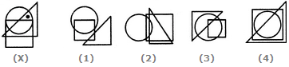

***Solution: (3)*** In figure (X), the dot is placed in the region which is common to the circle and triangle. Now, we have to search similar common region in the four options. Only in figure (3), we find such a region which is common to the circle and triangle.

Q.8) Question: Select the figure which satisfies the same conditions of placement of the dots as in Figure-X.

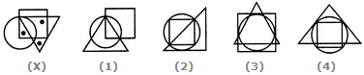

***Solution:***

In fig. (X), one of the dots lies in the triangle alone, another dot lies in the region common to the square and the triangle only and the third dot lies in the region common to the circle and the square only. In each of the figures (1), (2) and (4), there is no region common to the square and the triangle only. Only fig. (3) consists of all the three types of regions.

Q.9) Select the appropriate alternatives, from among the answer figures marked (1), (2), (3), (4) and (5), satisfying the similar conditions of placement of dot(s) as in the problem figure.

**Question 1**  


**Solution:** In the problem figure, one dot appers in a region common to both circle and rectangle only. Such a region is present in the answer figure (5). Choice (5)

**Question 10**  


In the problem figure, there are two dots. One dot appears in a region common to both circle and square only and another dot appears in a region common to both triangle and square only. Such a region is present only in the answer figure (1).  
Choice (1)

Analogy:

A Non-Verbal analogy is a kind of analogical reasoning to test the aptitude of students. It is a non-verbal test in which

 the questions have figures. These figures have some connection with each other. And to find the right answer, it is important

 to identify the relationship and difference.

 The following questions can help you understand the concept of figure analogy.

 figure available

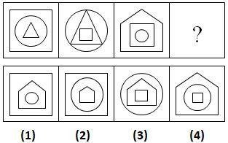

 As you can see from the above figure reasoning, the triangle is inside the circle. And the circle is inside a square. The second image shows that the square is inside a triangle. After that, the triangle is inside a circle.

Therefore, the answer to this figure is 2. It is because it has the same sequence as the second

Q.1) Select a suitable figure from the Answer Figures that would replace the question mark (?).

Problem Figures:                            Answer Figures:



    (A)     (B)      (C)     (D)                  (1)      (2)      (3)      (4)      (5)

A1

B2

C3

D4

E5

**Answer:** Option A

**Explanation:**

The figure gets vertically inverted.

Q.2) Select a suitable figure from the Answer Figures that would replace the question mark (?).

Problem Figures:                            Answer Figures:



    (A)     (B)      (C)     (D)                  (1)      (2)      (3)      (4)      (5)

1

2

3

4

5

**Answer:** Option E

**Explanation:**

The inner element enlarges to become the outer element while the outer element reduces in size, turns black and becomes the inner element.

Q.3) Select a suitable figure from the Answer Figures that would replace the question mark (?).

Problem Figures:                            Answer Figures:



    (A)     (B)      (C)     (D)                  (1)      (2)      (3)      (4)      (5)

1

2

3

4

5

**Answer:** Option E

**Explanation:**

The figure rotates through 90oACW and the arrowhead shifts closer to the black circle.

Q.4) Select a suitable figure from the Answer Figures that would replace the question mark (?).

Problem Figures:                            Answer Figures:



    (A)     (B)      (C)     (D)                  (1)      (2)      (3)      (4)      (5)

1

2

3

4

5

**Answer:** Option B

**Explanation:**

The figure gets rotated through 180o.

Q.5) Select a suitable figure from the Answer Figures that would replace the question mark (?).

Problem Figures:                            Answer Figures:



    (A)     (B)      (C)     (D)                  (1)      (2)      (3)      (4)      (5)

1

2

3

4

5

**Answer:** Option A

**Explanation:**

The pentagon gets vertically inverted. The lower half of the black element becomes white and this element moves inside the pentagon and gets attached to its upper end.

Q.6) Select a suitable figure from the Answer Figures that would replace the question mark (?).

Problem Figures:                            Answer Figures:



    (A)     (B)      (C)     (D)                  (1)      (2)      (3)      (4)      (5)

1

2

3

4

5

**Answer:** Option C

**Explanation:**

The figure rotates 90oACW and gets vertically inverted.

Q.7) Select a suitable figure from the Answer Figures that would replace the question mark (?).

Problem Figures:                            Answer Figures:



    (A)     (B)      (C)     (D)                  (1)      (2)      (3)      (4)      (5)

1

2

3

4

5

**Answer:** Option D

**Explanation:**

The elements move downwards along the diagonal and the lowermost element moves to the uppermost position. The triangle and the half shaded rectangle get vertically inverted and the pentagon rotates 90oCW.

Q.8) Select a suitable figure from the Answer Figures that would replace the question mark (?).

Problem Figures:                            Answer Figures:



    (A)     (B)      (C)     (D)                  (1)      (2)      (3)      (4)      (5)

1

2

3

4

5

**Answer:** Option B

**Explanation:**

The four parts at the outer ends of the figure are lost.

Q.9) Find the figure from the answer figure that will replace the question mark (?) from the problem figure.

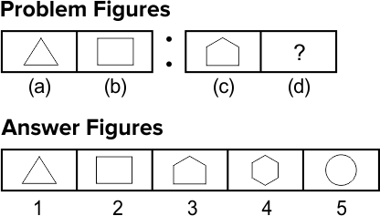

**Solution:** (4) By the careful analysis of first part of the problem figure, we find that first figure has three lines which become four in the second figure, i.e., form first to second figure one line is added. In the same manner, third figure has five lines which will transform into a six line figure in the fourth figure as shown in option (4).

Q.10)   
                    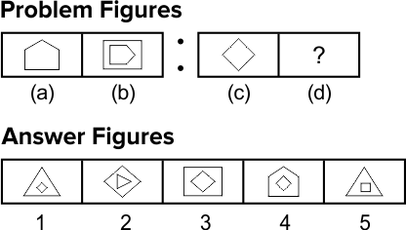

**Solution:** (1) From problem, figure (a) to (b), the pentagon rotates 900 clockwise, and a square (having four sides) covers it. Similarly, from figure (c) to (d) the square (having four sides) rotates 900 clockwise and will be covered by a triangle (having three sides).

Cubes and dices

Cube is a three-dimensional figure which can only be made out of a square. Square when given a height equal to one of the sides, becomes a cube. Die/Dice is a three-dimensional figure with each of its six sides/faces showing different numbers/letters/colours etc.

Important Facts of Cube and Dice

* A cube has 6 square faces or sides
* A cube has 8 points (vertices)
* A cube has 12 edges
* Only 3 sides of a cube are visible at a time (known as “Joint Sides”) and these sides can never be on the opposite side of each other
* Things that are shaped like a cube are often referred to as ‘cubic’
* Most dice are cube shaped, with the numbers 1 to 6 on the different faces.

Q.1) A dice is numbered from 1 to 6 in different ways.

If 1 is adjacent to 2, 4 and 6, then which of the following statements is necessarily true?

|  |  |
| --- | --- |
| A) 2 is opposite to 6 | B) 1 is adjacent to 3 |
| C) 3 is adjacent to 5 | D) 3 is opposite to 5 |

[Answer & Explanation](javascript:showans('5287','Cubes%20and%20Dice'))**Answer:** C) 3 is adjacent to 5  
  
**Explanation:**

If 1 is adjacent to 2, 4 and 6 then either 3 or 5 lies opposite to 1. So, the numbers 3 and 5 cannot lie opposite to each other. Hence, 3 is adjacent to 5 (necessarily).

Q.2) A dice is numbered from 1 to 6 in different ways.

If 1 is adjacent to 2, 3 and 5, then which of the following statements is necessarily true?

|  |  |
| --- | --- |
| A) 4 is adjacent to 6 | B) 2 is adjacent to 5 |
| C) 1 is adjacent to 6 | D) 1 is adjacent to 4 |

[Answer & Explanation](javascript:showans('5280','Cubes%20and%20Dice'))**Answer:** A) 4 is adjacent to 6  
  
**Explanation:**

If 1 is adjacent to 2, 3 and 5, then either 4 or 6 lies opposite to 1. So, the numbers 4 and 6 cannot lie opposite to each other. Hence, 4 necessarily lies adjacent to 6.

Q.3) Four usual dice are thrown on the ground. The total of numbers on the top faces of these four dice is 13 as the top faces showed 4, 3, 1 and 5 respectively. What is the total of the faces touching the ground?

|  |  |
| --- | --- |
| A) 12 | B) 13 |
| C) 15 | D) Cannot be determined |

[Answer & Explanation](javascript:showans('5286','Cubes%20and%20Dice'))**Answer:** C) 15  
  
**Explanation:**

In a usual dice, the sum of the numbers on any two opposite faces is always 7. Thus, 1 is opposite 6, 2 is opposite 5 and 3 is opposite 4.

Consequently, when 4, 3, 1 and 5 are the numbers on the top faces, then 3, 4, 6 and 2 respectively are the numbers on the face touching the ground. The total of these numbers = 3 + 4 + 6 + 2 = 15.

Q.4) Find the total number of cubes in the given figure ?

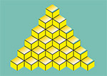

|  |  |
| --- | --- |
| A) 56 | B) 60 |
| C) 64 | D) 72 |

[Answer & Explanation](javascript:showans('10905','Cubes%20and%20Dice'))**Answer:** A) 56  
  
**Explanation:**

(Total numbers of cubes in a line  x  Number of stack / tower) + ...

= (6x1)+(5x2)+(4x3)+(3x4)+(5x2)+(6x1)

= 6+10+12+12+10+6 = 56

Q.5) In a dice a, b, c and d are written on the adjacent faces, in a clockwise order and e and f at the top and bottom. When c is at the top, what will be at the bottom?



a

b

c

d

**Answer:** Option A

**Explanation:**

Clearly, the six faces are labelled as

Face I -> a, Face IV -> b, Face III -> c, Face II -> d, Face V -> e, Face VI -> f

Therefore 'a' appears opposite 'c'.

Hence, when 'c' is at the top, then 'a' will be at the bottom.

Q.6) The four different positions of a dice are given below: Find the number on the face opposite the face showing 6?

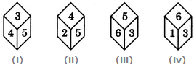

1

2

4

5

**Answer:** Option C

**Explanation:**

From figures (i), (ii) and (iii), we conclude that 3, 4, 2 and 6 lie adjacent to 5. Therefore, 1 must lie opposite 5.

From figures (i), (iii) and (iv), we conclude that 4, 5, 6 and 1 lie adjacent to 3. Therefore, 2 must lie opposite 3. Now, we have 1 opposite 5 and 2 opposite 3. Hence, 4 must lie opposite 6.

Q.7) A cube has six different symbols drawn over its six faces. The symbols are dot, circle, triangle, square, cross and arrow. Three different positions of the cube are shown in figures X, Y, and Z.

Which symbol is opposite the arrow?

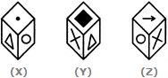

Circle

Triangle

Dot

Cross

**Answer:** Option B

**Explanation:**

From figures X and Y, we conclude that dot, circle, square and cross lie adjacent to the triangle. Therefore, the arrow must lie opposite the triangle. From figures X and Z, we conclude that dot, triangle, arrow and cross lie adjacent to the circle. Therefore, the square must lie opposite the circle. Thus, the arrow lies opposite the triangle, the square lies opposite the circle and consequently, the cross lies opposite the dot.

As analysed above, the symbol opposite the arrow is the triangle.

Q.8) A dice is numbered from 1 to 6 in different ways.

If 1 is adjacent to 2, 4 and 6, then which of the following statements is necessarily true?

2 is opposite to 6

1 is adjacent to 3

3 is adjacent to 5

3 is opposite to 5

**Answer:** Option C

**Explanation:**

If 1 is adjacent to 2, 4 and 6 then either 3 or 5 lies opposite to 1. So, the numbers 3 and 5 cannot lie opposite to each other. Hence, 3 is adjacent to 5 (necessarily).

Q.9) **How many cubes are there in below figure?**

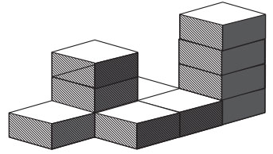

1. 
   1. 10



* 1. 11



* 1. 12



* 1. 13

1. [View Hint](https://interviewmania.com/non-verbal-reasoning/cubes-and-dices) [View Answer](https://interviewmania.com/non-verbal-reasoning/cubes-and-dices) [Discuss in Forum](https://interviewmania.com/discussion/27259-non-verbal-reasoning-cubes-and-dices)

##### Correct Option: B

4 columns with 1 cubes = 4 cubes  
1 columns with 3 cubes = 3  
1 columns with 4 cubes = 4  
Total cubes = 4 + 3 + 4 = 11

Q.10) Four positions of a dice are given below. Identify the number at the bottom when the number on the top is **2**.

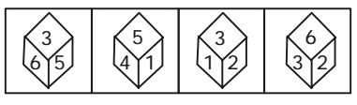

1. 
   1. 6



* 1. 3



* 1. 4



* 1. 5

1. [View Hint](https://interviewmania.com/non-verbal-reasoning/cubes-and-dices/1/3) [View Answer](https://interviewmania.com/non-verbal-reasoning/cubes-and-dices/1/3) [Discuss in Forum](https://interviewmania.com/discussion/34175-non-verbal-reasoning-cubes-and-dices)

##### Correct Option: D

On the basis of question figure pattern ,  
The numbers **1, 2, 5 and 6** are on the faces adjacent to the number **3**.  
Therefore, **4** lies opposite **3**.  
The numbers **2, 3, 4 and 5** are on the faces adjacent to the number **1**.  
Therefore, **6** lies opposite **1**.  
Now, the number **5** lies opposite **2**.

Rule Detection

Rule Detection is an interesting idea in the world of logical thinking. It's about finding hidden rules or patterns in information. This skill helps us solve problems, make decisions, and understand how things work, especially in complex situations.

This type of Reasoning questions requires your imaginary as well as logical skills. When you practice with different figures and shapes, you develop a different mindset and thus this allows you to imagine out-of-box.

Example: Which of the following series of figures follows the given rule?

Rule: As the square decreases in size, its parts increase in number.

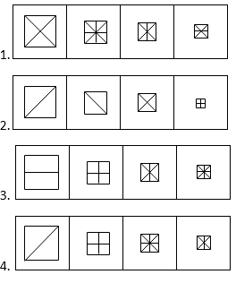

Answer 3) Only the third series follows the given rule.

Q.1) Choose the set of figures which follows the given rule.

**Rule:**Closed figures gradually become open and open figures gradually become closed.

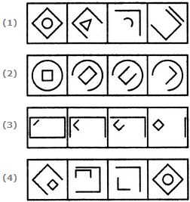

1

2

3

4

Answer: Option c

Q.2) Choose the set of figures which follows the given rule.

**Rule:**Closed figures become more and more open and open figures become more and more closed.

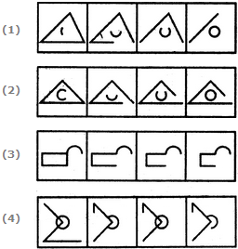

|  |  |
| --- | --- |
| A) 1 | B) 2 |
| C) 3 | D) 4 |

[Answer & Explanation](javascript:showans('5191','Rule%20Detection'))**Answer:** A) 1

Q.3) Rule: The image becomes simpler as the series proceeds.

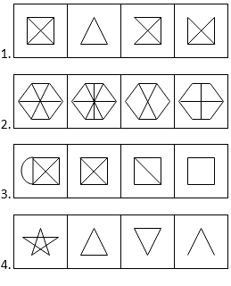

Hide Answer Workspace

**Answer:** C

**Explanation:**

In the third series, the image becomes simpler as the series proceeds.

Q.4) Which of the following set of figures follows the given rule?  
**Rule:** Closed figure becomes more and more open.  
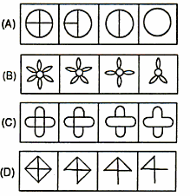

Answer: Option D

**Solution**: A close observation of the sets of figures reveals that in set of figures (D), a closed figure, a square divided into four parts, tend to become open in each step. Hence (D) is the answer.

Q.5) The image becomes complex as the series proceeds.

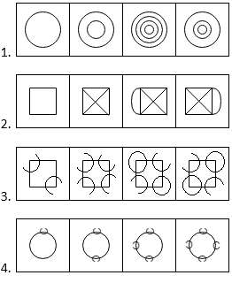

1. 1
2. 2
3. 3
4. 4

**Answer:** D

**Explanation:**

Only the fourth series follows the given rule.

Q.6) Out of the following figures, which figure is closed initially and will be opened gradually and which open figure will be closed?



The correct answer is (3).

Q.7) Choose the set of figures which follows the given rule.

**Rule:**Closed figures become more and more open and open figures become more and more closed.

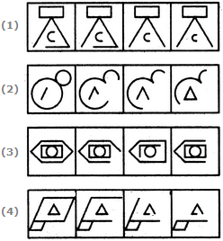

|  |  |
| --- | --- |
| A) 1 | B) 2 |
| C) 3 | D) 4 |

[Answer & Explanation](javascript:showans('5195','Rule%20Detection'))**Answer:** B) 2

Q.8) Choose the set of figures which follows the given rule.

**Rule:**Closed figures become more and more open and open figures become more and more closed.



|  |  |
| --- | --- |
| A) 1 | B) 2 |
| C) 3 | D) 4 |

[Answer & Explanation](javascript:showans('5191','Rule%20Detection'))**Answer:** A) 1

Q.9) Rule: The image becomes simpler as the series proceeds.



1. 1
2. 2
3. 3
4. 4

Hide Answer Workspace

**Answer:** C

**Explanation:**

In the third series, the image becomes simpler as the series proceeds.

Q.10)  A single unbroken line can trace any figure in the series without retracting.

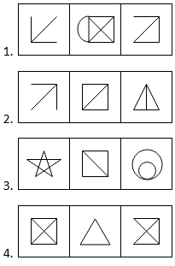

1. 1
2. 2
3. 3
4. 4

Hide Answer Workspace

**Answer:** C

**Explanation:**

Only the third series follows the given rule.

Classification

This type reasoning called 'Classification' covers several different criteria which can be applied to classify the given items into a particular group. This classification can be based on some common properties which they possess like shape, number of sides, division of figures etc. Here, the object which possess these common properties are classified into the same group while the object which does not possess these common properties (i.e., the odd one) is to be eliminated from the group.

Classification and odd one out question aims to judge the candidate’s information processing capabilities, creative thinking ability, and evaluation skills.

Example: 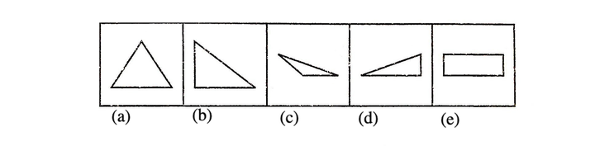

**Solution:** Except figure (e), all have three sides but in figure (e) there are four sides.so answer is (e)

### Q.1) **. Pick the odd word from the given list.**

A.Lamprey  
B.Rhea  
C.Bass  
D. Trout

***Answer:****B.Rhea.****Explanation:-*** *All the others except Rhea, are names of fishes.*

### Q.2) **Pick the odd one out from the given pair of words.**

A.Peace:Fight  
B.Rough:mooth  
C.Coward:Timid  
D. Taciturn: Talkative

***Answer:****C.Coward:Timid****Explanation:-*** *Except for pair C, all of the words are antonyms. The terms in option C, on the other hand, are synonyms.*

### Q.3) **Find the odd number in the below list.**

A. 7121  
B. 7061  
C. 8154  
D. 7391

***Answer:****C. 8154*

***Explanation:-****All the other numbers, except for option C, start with 7 and ends with 1.*

Q.4) Choose the word which is different from the rest.

Curd

Butter

Oil

Cheese

Cream

**Answer:** Option C

**Explanation:**

All except Oil are products obtained from milk.

Q.5) Choose the word which is different from the rest.

Tall

Huge

Thin

Sharp

Small

**Answer:** Option D

**Explanation:**

All except Sharp are related to dimension.

Q.6) Choose the word which is different from the rest.

Dagger

Hammer

Knife

Sword

Blade

**Answer:** Option B

**Explanation:**

All except Hammer are sharp-edged and have a cutting action.

Q.7) Choose the word which is different from the rest.

Calendar

Year

Date

Month

Day

**Answer:** Option A

**Explanation:**

All others are parts of a calendar.

Q.8) Choose the word which is different from the rest.

Biscuits

Chocolate

Cake

Bread

Pastry

**Answer:** Option B

**Explanation:**

All except Chocolate are baked items.

Q.9) Find the odd one out

|  |  |
| --- | --- |
| A) Flower : Petal | B) Circle : Arc |
| C) Cover : Page | D) Chair : Leg |

[Answer & Explanation](javascript:showans('1708','Classification'))**Answer:** C) Cover : Page  
  
**Explanation:**

In all other pairs, second is a part of the first.

Q.10) Three of the following four are alike in a certain way and hence form a group. Which is the one that does not belong to that group?

|  |  |
| --- | --- |
| A) Rice | B) Wheat |
| C) Barley | D) Mustard |

[Answer & Explanation](javascript:showans('8204','Classification'))**Answer:** D) Mustard  
  
**Explanation:** Except Mustard each belongs to the same category, viz foodgrains. Mustard is an oil seed.

Mirror Images and Reflection

The image of an [object](https://www.toppr.com/guides/science/sorting-materials-into-group/objects-around-us/) as seen in a mirror is its [mirror reflection](https://www.toppr.com/guides/physics/light-reflection-and-refraction/reflection-of-light-by-plane-mirror/) or mirror image. In such an image, the right side of the object appears on the left side and vice versa. A mirror-image is therefore said to be laterally inverted and the [phenomenon](https://www.toppr.com/guides/physics/ray-optics-and-optical-instruments/some-natural-phenomenon-due-to-sunlight/) is called the lateral inversion.

### **Mirror Images and Reflection Includes Following Types:**

### **1**. **Mirror Image of letters:**

The case is related to a mirror image of letters and numbers. Some letters do not change upon reflection. The letters which are having identical mirror images are A, H, I, M, O, T, U, V, W, X, and Y. Similarly in small letters we have i, l, o, v, w, and x that have the same mirror image as that of their original images.

### 2. Mirror Image of numbers :8 is the only numeral that have the same mirror image as that of its original.

### **3**. **Shape Mirror Image :**

The point of an object near the mirror will be always near the mirror image also

Q.1) Choose the alternative which is closely resembles the mirror image of the given combination.

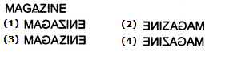

1

2

3

4

**Answer:** Option d

Q.2) Choose the alternative which is closely resembles the mirror image of the given combination.  
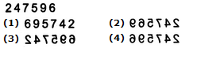

1

2

3

4

**Answer:** Option d

Q.3) Choose the alternative which is closely resembles the mirror image of the given combination.  
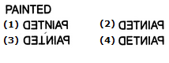

1

2

3

4

**Answer:** Option b

Q.4) Choose the alternative which is closely resembles the mirror image of the given combination.  
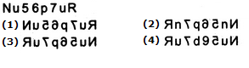

1

2

3

4

**Answer:** Option c

Q.5) If the mirror is placed on the line XY, then identify the correct mirror image of the given question figure from the answer figures.

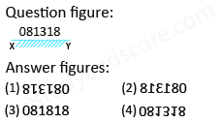

* A)

2

* B)

4

@

* C)

3

* D)

1

**Answer: Option B**

**Explanation**

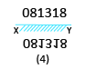

In the mirror image,  
• The right side of the object becomes the left side  
• The left side of the object becomes the right side  
• The top and bottom sides of the object remain unchanged

**Hence answer figure 4 is correct.**

Q.6)

**Select the mirror image of the following figure.  
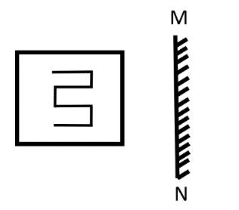**

(A) 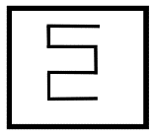 (B) 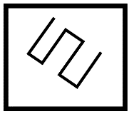 C) 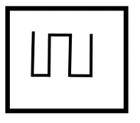 (D) 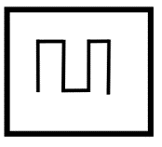

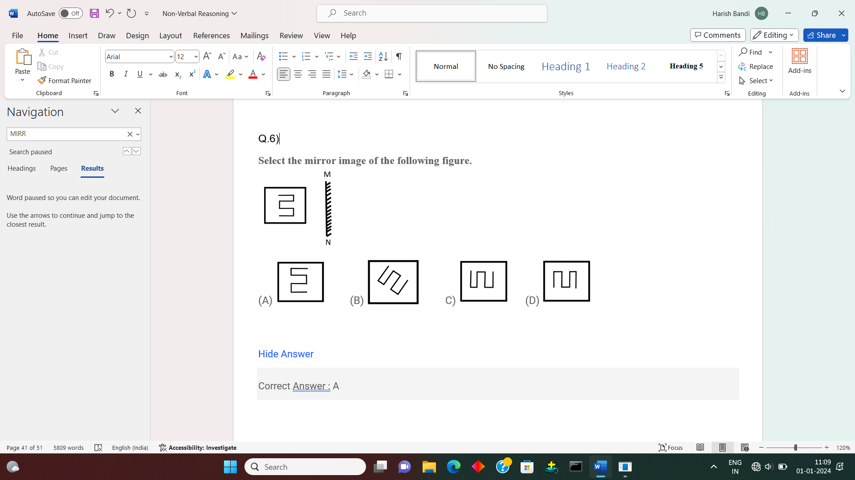

[Hide Answer](https://www.examsbook.com/mirror-image-questions-and-answers)

Correct Answer : A

Q.7) **Q :**

**If a mirror is placed on a line MN, which of the given answer figures will be the correct image of the question figure?**

PA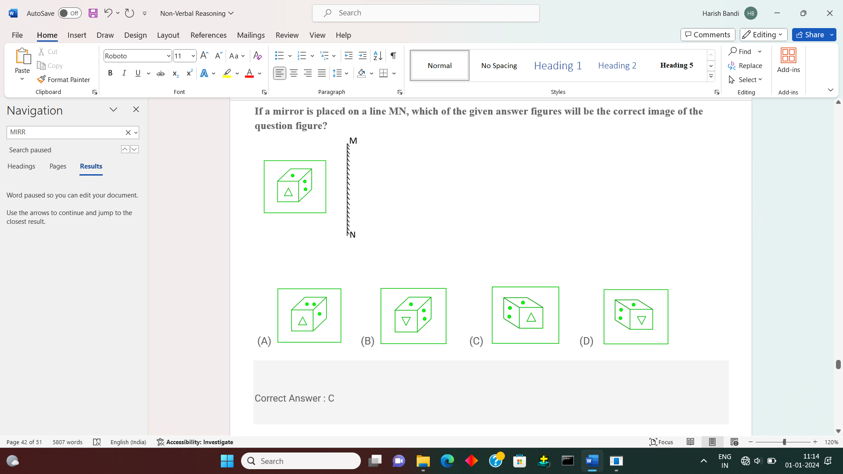

Correct Answer : C

Q.8) If a mirror is placed on the **line MN**, then which of the answer figures is the correct image of the given question figure?

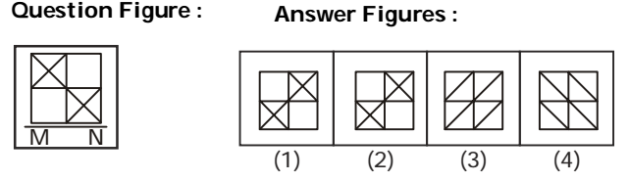

1. 
   1. 1



* 1. 2



* 1. 3



* 1. 4

CORRECT OPTION: B

Q.9) Choose the correct mirror image of the given figure (X) from amongst the four alternatives.

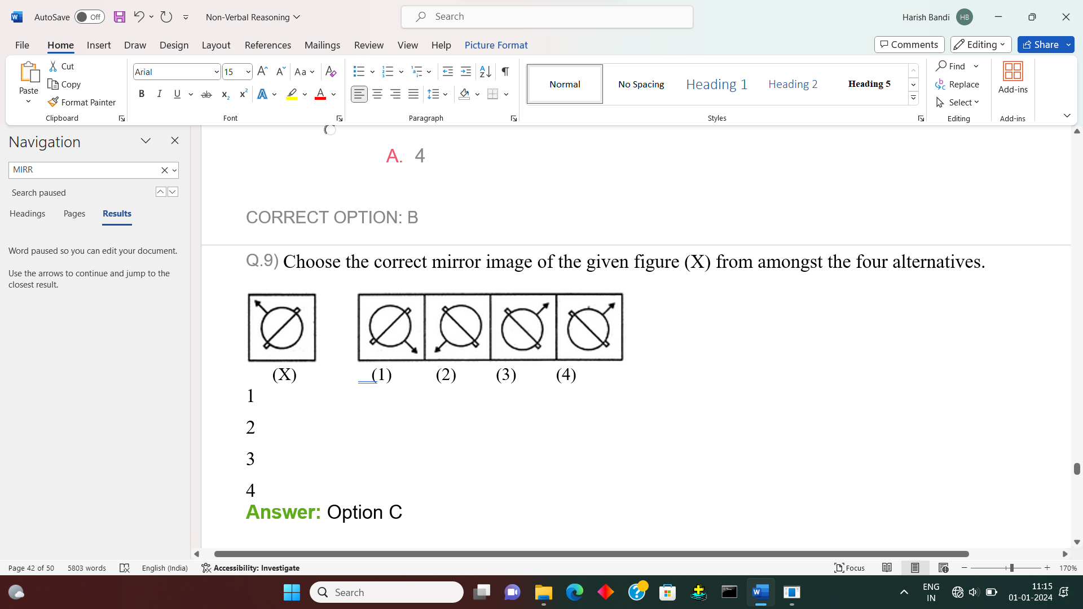

1

2

3

4

**Answer:** Option C

Q.10) Choose the correct mirror image of the given figure (X) from amongst the four alternatives.

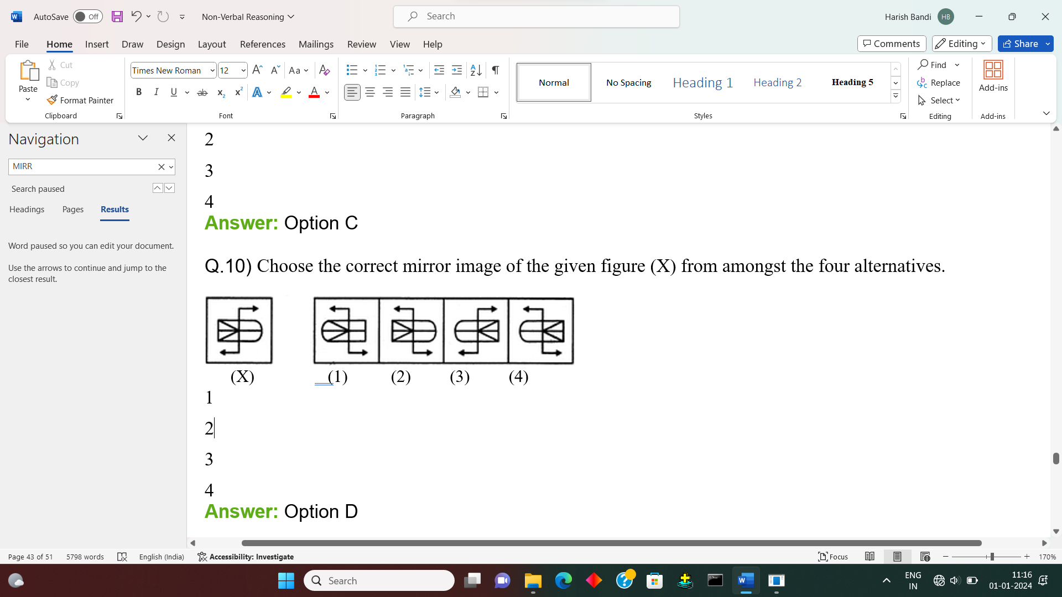

1

2

3

4

**Answer:** Option D

Counting of figures

In the Figure Counting reasoning section, figure counting refers to the process of formation of a defined geometrical figure with the use of pieces of different designs. for the counting of figures, you have a shape or a figure. From the given shape you will have to identify a given known shape and count the [number](https://www.toppr.com/guides/maths/playing-with-numbers/general-form-of-a-number/) of times it is present in the given shape.

Example: How many Tringles in the below figure.

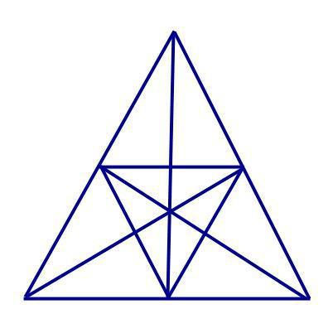

### Answer: There are a total of 47 triangles

**How?**  
we will divide this triangle into 3 equal triangles(triangle formed by connecting outer side to the center of the circle) and will count the number of triangles in each part and then by taking two or more parts together.

**Number of triangles in one part**: 4(non overlapping) + 3(overlapping) = **7 * 3 = 21**  
**Number of triangles by taking two parts together**: 8 = **8 * 3 = 24**  
**Number of triangles by taking all three parts together**: **2**

### Thus, total number of triangles in this puzzle are : 21+24+2= 47

**Q.1) In question below shown, count the number of triangle and squares.**

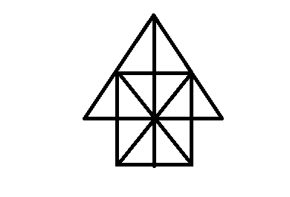

(A) 26 triangles, 5 squares

(B) 28 triangles, 5 squares

(C) 26 triangles,6 squares

(D) 28 triangles, 6 squares

[Hide Answer](https://www.examsbook.com/figure-counting-questions-with-answers)

Correct Answer : A  
Explanation :

The simplest triangle is shown in figure is 12 and another is IBO, BDO, DGO, GIO, ABO,CBD, DEO, IBD,BDG, DGI, GIB, ACO and COE and ACE is the total no of traingle are 12+14=26

Q.2) **How many triangles in the figure?**

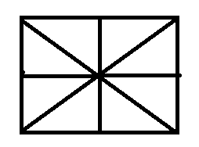

(A) 16

(B) 14

(C) 8

(D) 12

[Hide Answer](https://www.examsbook.com/figure-counting-questions-with-answers)

Correct Answer : A  
Explanation :

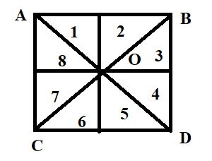

in the figure the 8 triangle is shown easily and another is COD , DOB, BOA, AOC, ACD, BDC,ABC, ABD so that total no. of triangle is 8+8=16

Q.3) **How many triangle is in the given figure?**

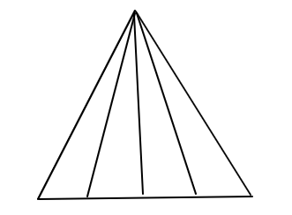

(A) 10

(B) 12

(C) 14

(D) 16

[Hide Answer](https://www.examsbook.com/figure-counting-questions-with-answers)

Correct Answer : A  
Explanation :

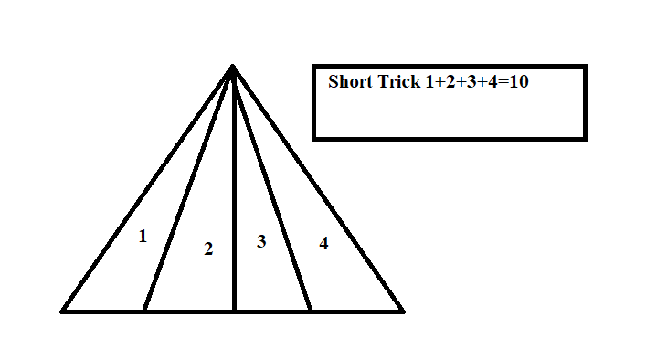

Q.4) **How many triangles are in the figure?**

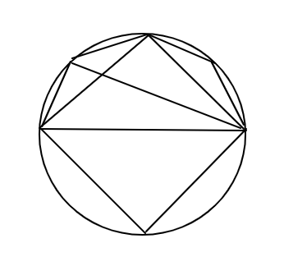

(A) 10

(B) 8

(C) 12

(D) 11

Correct Answer : A  
Explanation :

The triangle 6 shown in figure and another is ADB,ACB, BDC,ADC, so that total number of triangle is 10  
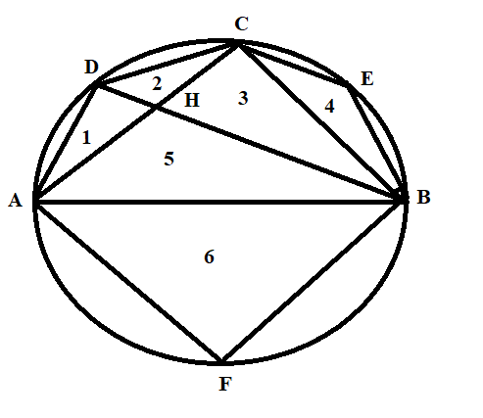

Q.5) **How many squares in the figure?**

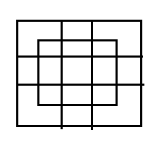

(A) 16

(B) 18

(C) 25

(D) 27

[Hide Answer](https://www.examsbook.com/figure-counting-questions-with-answers/2)

Correct Answer : D  
Explanation :

In this figure counting the squares and we get the 27 squares.

Q.6) **Find the number of triangles?**

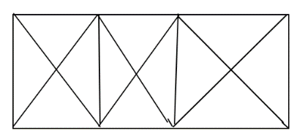

(A) 29

(B) 25

(C) 28

(D) 24

[Hide Answer](https://www.examsbook.com/figure-counting-questions-with-answers/2)

Correct Answer : C  
Explanation :

in the above figure it consist 8 triangle so that no. of square is 3 so that total no. of triangle is 8 ✖ 3=24

and 4 triangle shown in question figure so that answer is 24+4=28 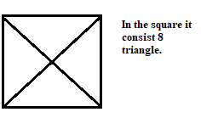

Q.7) **Find the number of rectangles?**

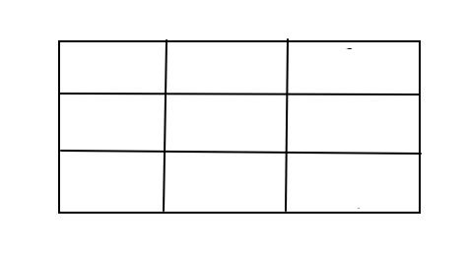

(A) 19

(B) 28

(C) 27

(D) 36

Correct Answer : D  
Explanation :

First mark each rectangles 1, 2 and 3 after we can cube of 1 +8+27=36 we get the answer

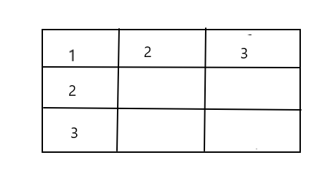

Q.8) **Find the number of triangles in the given figure.  
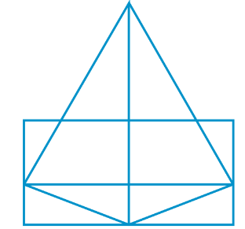**

(A) 8

(B) 15

(C) 20

(D) 25

[Hide Answer](https://www.examsbook.com/figure-counting-questions-with-answers/3)

Correct Answer : B

Q.9) **What is the number of**straight lines**in the following figure?**

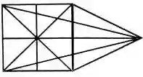

A) 10  
B) 12  
C) 13  
D) 17

[Hide answer](https://reasoningquestions.in/counting-of-figures-reasoning-questions-and-answers/)

**Answer: (B)  
Solution:** label the figure as shown below:  
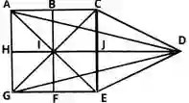  
clearly in this figure:  
There are 3 horizontal lines namely AG, BF, and CE.  
There are 3 vertical lines namely AC, HD, and GE.

There are 6 slanting lines namely AD, AE, GC, GD, CD, AND CE.  
Thus, There are 3+3+6=12  straight lines in all.

Q.10) **How many Triangles are there in the following figure?**

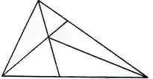

A) 6  
B) 10  
C) 11  
D) 12

[Hide answer](https://reasoningquestions.in/counting-of-figures-reasoning-questions-and-answers/)

**Answer: (D)  
Solution:** The figure may be labeled As shown below:  
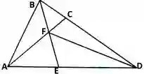  
The simplest triangle is ABE, BEF, EFC, CDE, AND AED i.e. 5 In number.  
The Triangles are composed of two components each are ABF, BCE, ACE, and ABD i.e. 4 In number.  
There is only one Triangle ABC  composed of five components. Thus 5+4+2+1 =12 Triangles in the figure.